1.Ajax call for two inputs

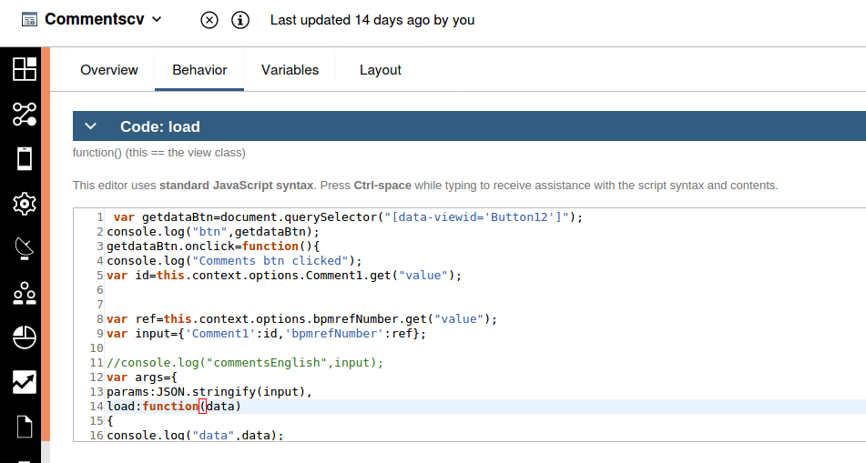

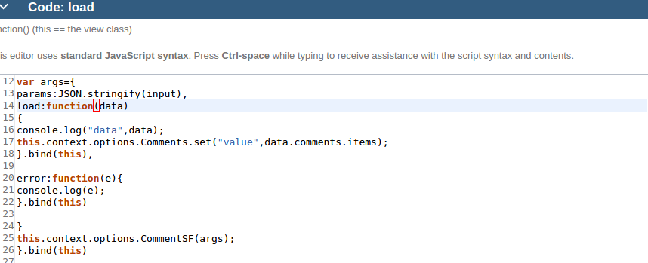

2.Ajax call one input
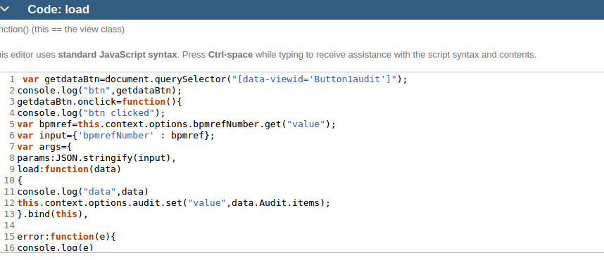

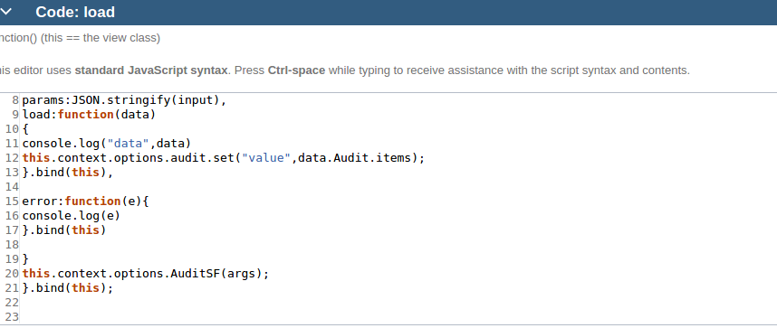
3.Ajax for displaying output

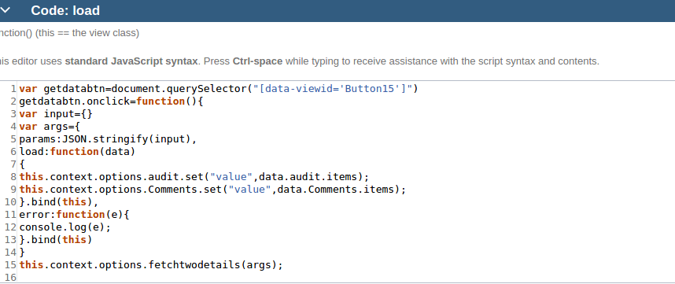
}.bind(this)

4.Ajax call for clear

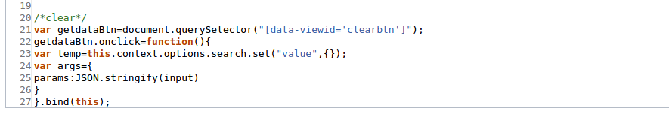

5.Ajax call for Search

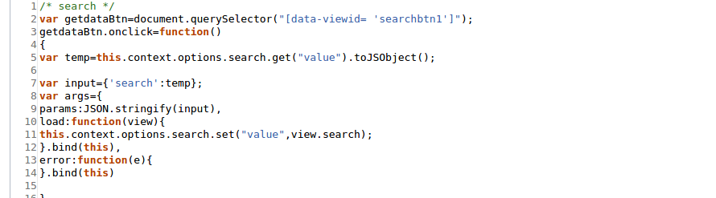

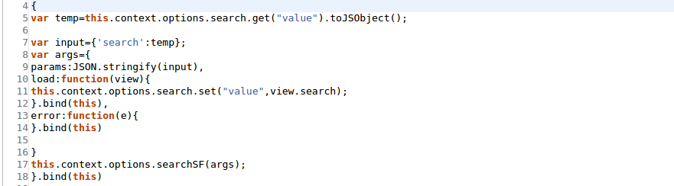

6.if any field is empty,this code will display alert to enter atleast one field,the should dbe written in boundary event

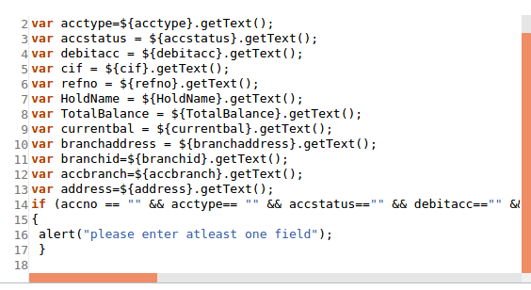

7.code for clear

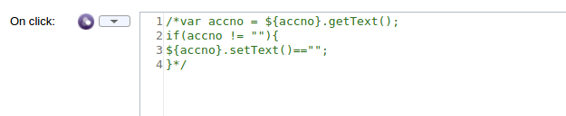

8.comments sf

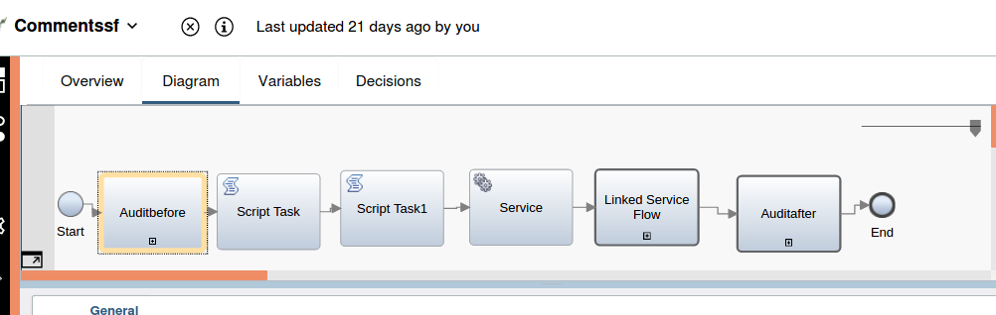

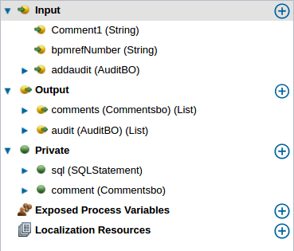

1.Audit before

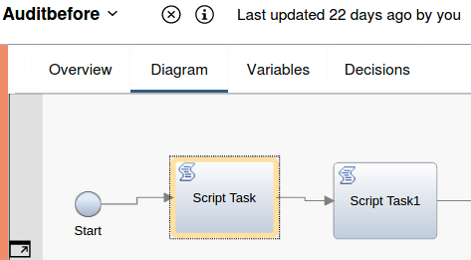

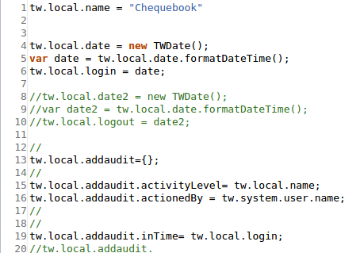

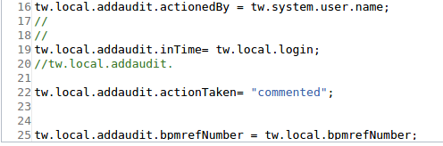

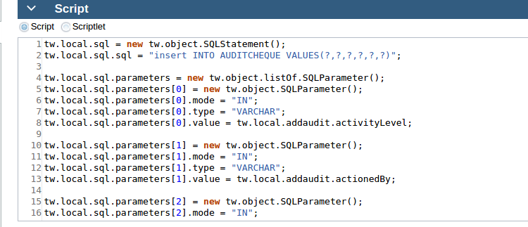

8.2 script task

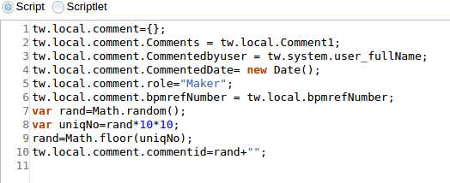
8.3inserting code comment table

8.4 service

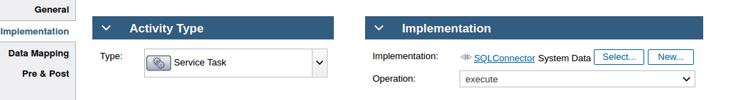

8.5 fetching data

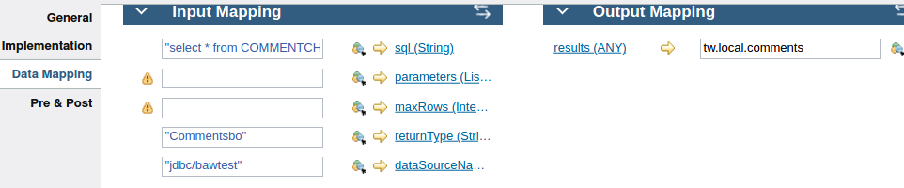

8.6 Audit after

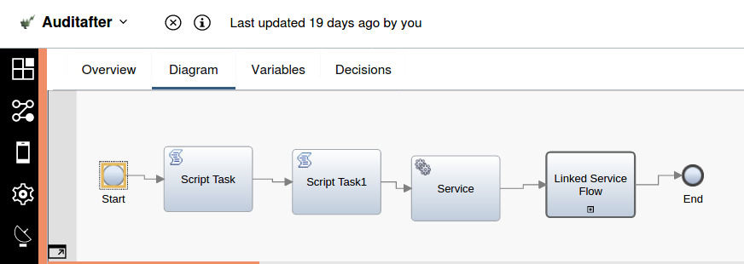

script task

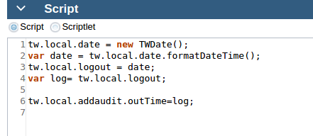

script task1: insert code
service
linked service: audit sf (fetch code)

9 logout button

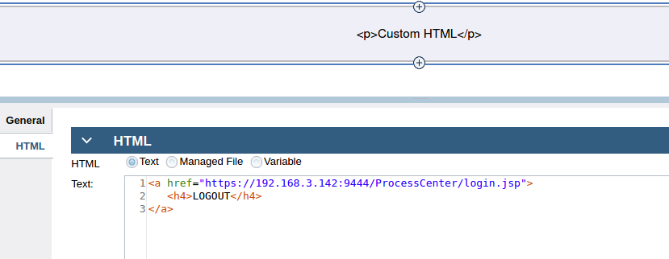

10. username

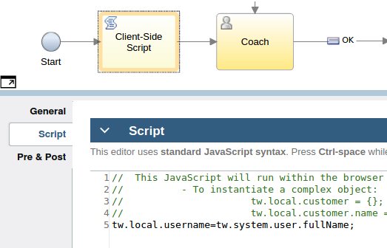

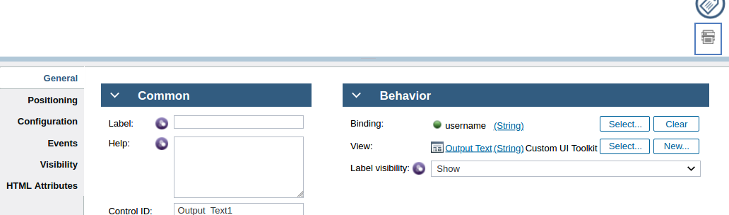

11.twsearch

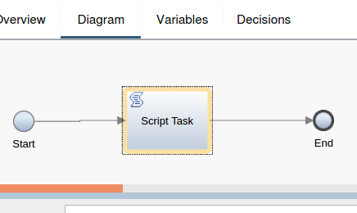

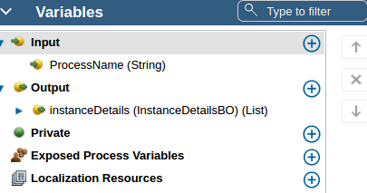

var search = new TWSearch(); // define object

var colInstanceId = new TWSearchColumn(); // coulm define
colInstanceId.type = TWSearchColumn.Types.ProcessInstance;
colInstanceId.name = TWSearchColumn.ProcessInstanceColumns.ID;

var colInstanceStatus = new TWSearchColumn();
colInstanceStatus.type = TWSearchColumn.Types.ProcessInstance;
colInstanceStatus.name = TWSearchColumn.ProcessInstanceColumns.Status;

var colInstanceName = new TWSearchColumn();
colInstanceName.type = TWSearchColumn.Types.ProcessInstance;
colInstanceName.name = TWSearchColumn.ProcessInstanceColumns.Name;

var colTaskId = new TWSearchColumn();
colTaskId.type = TWSearchColumn.Types.Task;
colTaskId.name = TWSearchColUpdate Priorityumn.TaskColumns.ID;

var colTaskStatus = new TWSearchColumn();
colTaskStatus.type = TWSearchColumn.Types.Task;
colTaskStatus.name = TWSearchColumn.TaskColumns.Status;
Update Priority
var colClosedDateTime = new TWSearchColumn();
colClosedDateTime.type = TWSearchColumn.Types.Task;
colClosedDateTime.name = TWSearchColumn.TaskColumns.ClosedDate;

var colDueDateTime = new TWSearchColumn();
colDueDateTime.type = TWSearchColumn.Types.Task;
colDueDateTime.name = TWSearchColumn.TaskColumns.DueDate;

var priority=new TWSearchColumn();
priority.type=TWSearchColumn.Types.Task;
priority.name=TWSearchColumn.TaskColumns.Priority;

search.columns=new
Array(colInstanceId,colInstanceStatus,colInstanceName,colTaskId,
colTaskStatus,colClosedDateTime,colDueDateTime,priority);

var condInstanceName = new TWSearchCondition; // condtion
condInstanceName.column = colInstanceName;
condInstanceName.operator = TWSearchCondition.Operations.StartsWith;
condInstanceName.value = ""+tw.local.ProcessName+"";
//condInstanceName.value = "Main Process";

var conditions = new Array(condInstanceName);
search.conditions = conditions;

var orderInstanceId = new TWSearchOrdering(); // ordering
orderInstanceId .column = colInstanceId;
orderInstanceId .order = TWSearchOrdering.Orders.Descending;
search.orderBy = new Array(orderInstanceId);
search.organizedBy = TWSearch.OrganizeByTypes.Task;

var results = search.execute(); // exceute
tw.local.instanceDetails=new tw.object.listOf.InstanceDetailsBO();

for ( var i = 0 ; i < results.rows.length ; i++ ) {

var row=results.rows[i];
tw.local.instanceDetails[i]=new tw.object.InstanceDetailsBO();
tw.local.instanceDetails[i].instanceId=row.values[0].toString();
tw.local.instanceDetails[i].instanceStatus=row.values[1].toString();
tw.local.instanceDetails[i].instanceName=row.values[2].toString();
tw.local.instanceDetails[i].taskId=row.values[3].toString();
tw.local.instanceDetails[i].taskStatus=row.values[4].toString();
tw.local.instanceDetails[i].closedDate=row.values[5];
tw.local.instanceDetails[i].dueDate=row.values[6];
tw.local.instanceDetails[i].priority=row.values[7].toString();
}

11.. Ajax using bo as input

var getdataBtn=document.querySelector("[data-viewid='Button1search']");

console.log("btn load",getdataBtn);

console.log("btn clicked");

getdataBtn.onclick=function(){
var temp=this.context.options.search.get("value").toJSObject();
var input={'search':temp};
var args={

params:JSON.stringify(input),

load:function(view){

console.log("data",view);

this.context.options.search.set("value",view.search);

}.bind(this),

error:function(e){

console.log(e);

}.bind(this)

}

this.context.options.storedSF(args);

}.bind(this)

12. Error boundary event

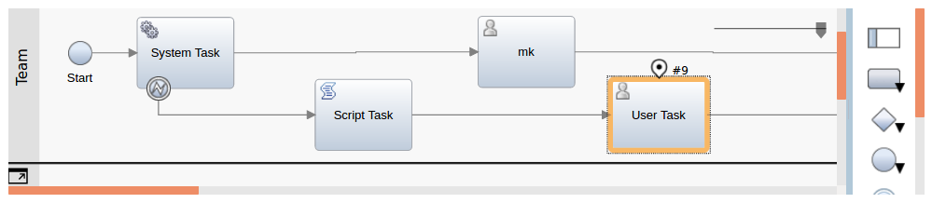

tw.local.errorDetails = new tw.object.ErrorBO();

tw.local.errorDetails.error = "Error From Backend";

var pid = tw.system.currentProcessInstance.id.split('.');
tw.local.errorDetails.processId = pid[1];
tw.local.errorDetails.processName = tw.system.currentProcessInstance.name;
tw.local.errorDetails.status = tw.system.currentProcessInstance.status;

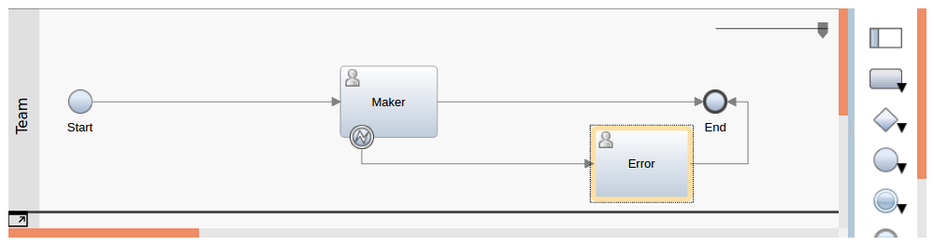

We have take one user task and bind user interface in user task containing some error and take another user task ,attach error boundary evnet to user task,it will handle the error

13..Document

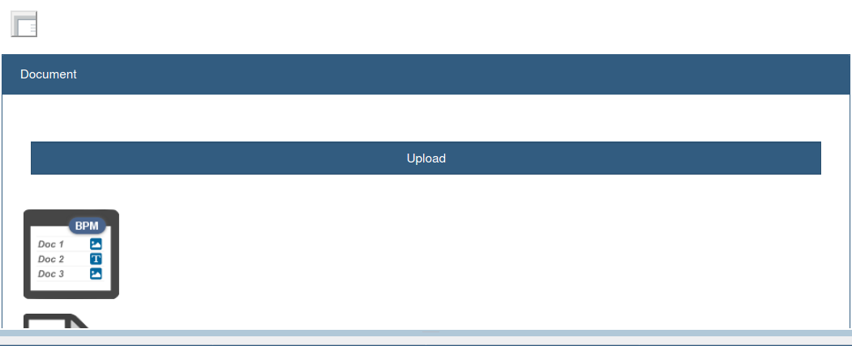

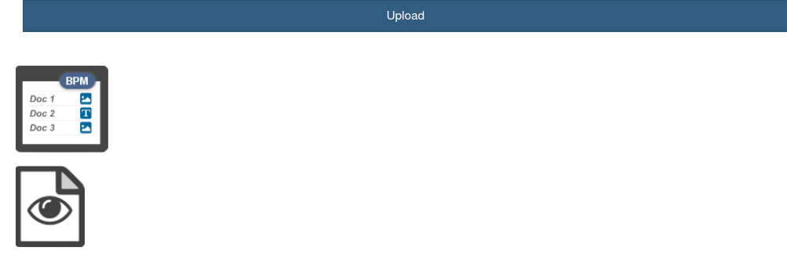

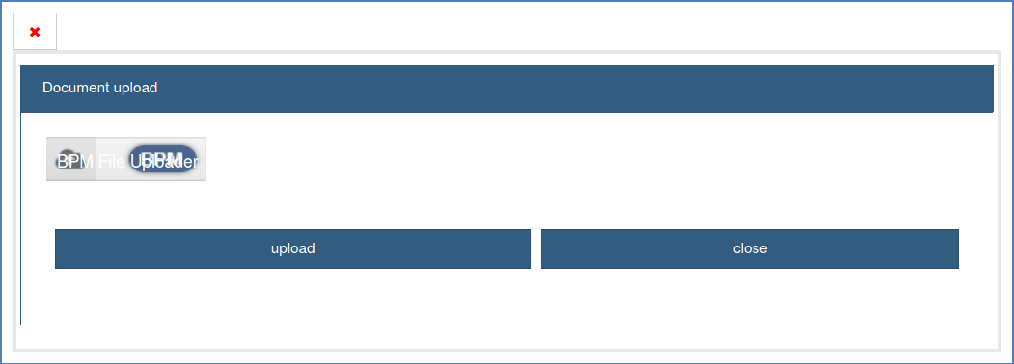

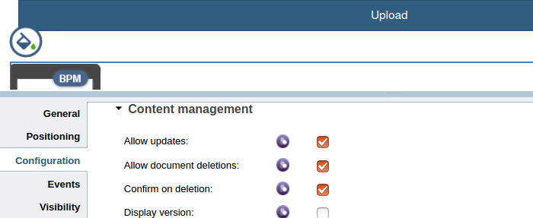

in bpm file list ,we have to enable this buttons

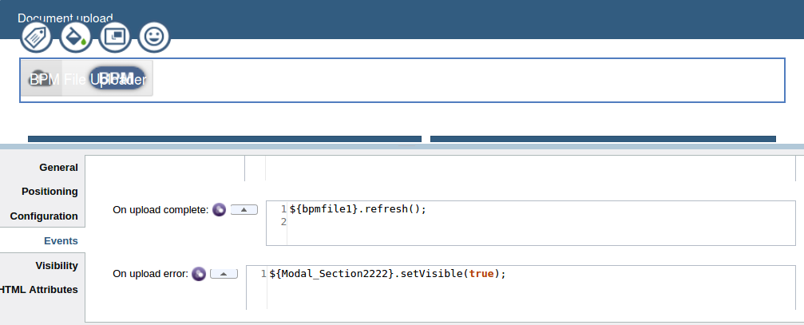

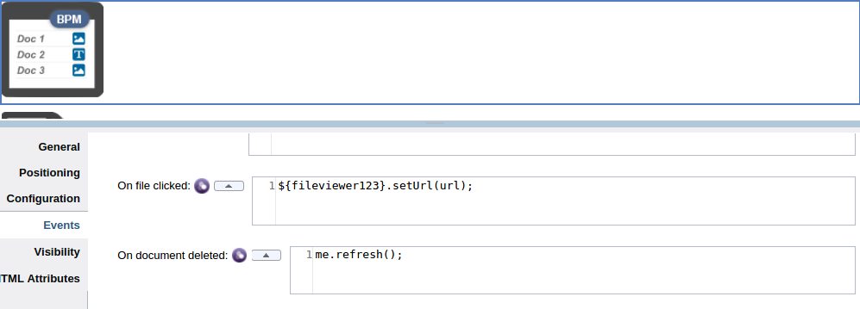

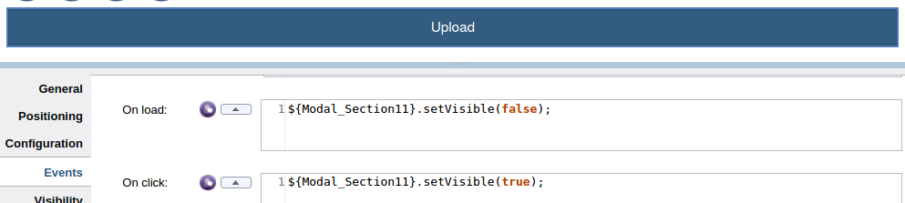
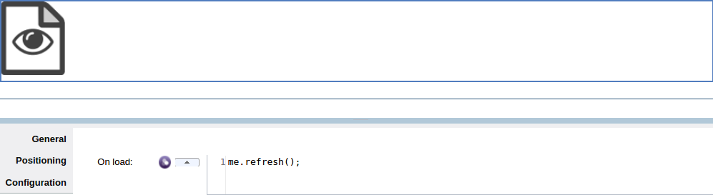

14..converting list bo to normal bo

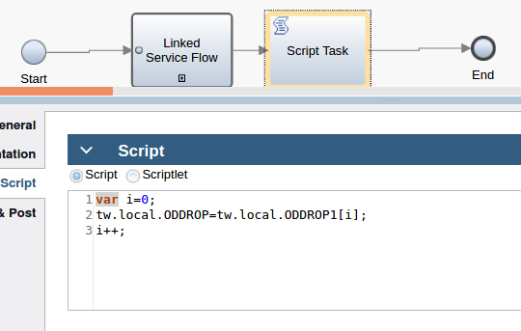

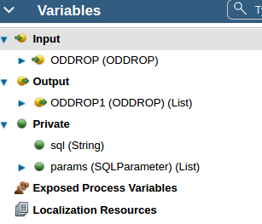

15..Comments cv

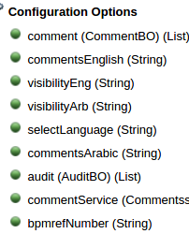

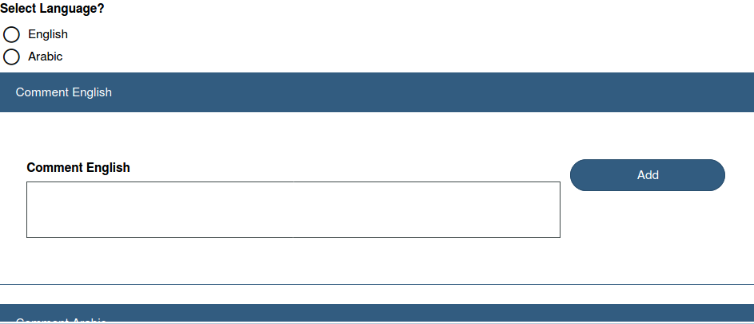

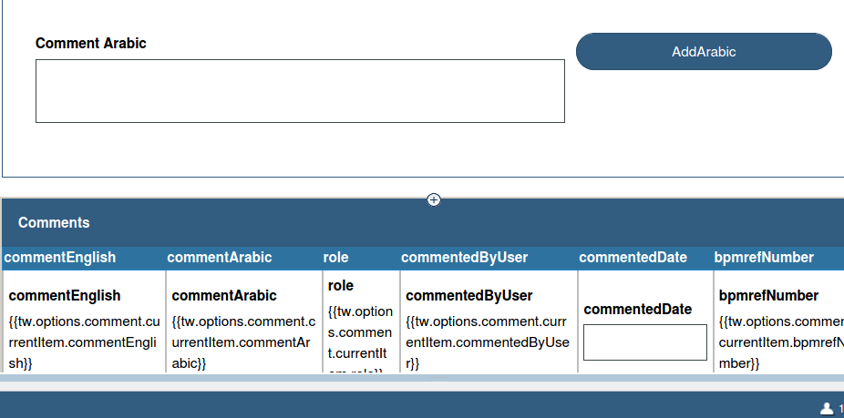

var getdataBtn=document.querySelector("[data-viewid='Button1add']");
console.log("btn",getdataBtn);
getdataBtn.onclick=function(){
console.log("btn clicked");
var id=this.context.options.commentsEnglish.get("value");

var ref=this.context.options.bpmrefNumber.get("value");
var input={'commentsEnglish':id,'bpmrefNumber':ref};

//console.log("commentsEnglish",input);
var args={
params:JSON.stringify(input),
load:function(data)
{
console.log("data",data);
this.context.options.comment.set("value",data.comments.items);
}.bind(this),

error:function(e){
console.log(e);
}.bind(this)

}
this.context.options.commentService(args);
}.bind(this)

//2
var getdataBtn=document.querySelector("[data-viewid='Button2arabic']");
console.log("btn",getdataBtn);
getdataBtn.onclick=function(){
console.log("btn clicked");
var id=this.context.options.commentsArabic.get("value");
var ref=this.context.options.bpmrefNumber.get("value");
var input={'commentsArabic':id,'bpmrefNumber':ref};
console.log("commentsArabic",input);
var args={
params:JSON.stringify(input),
load:function(data)
{
console.log("data",data);
this.context.options.comment.set("value",data.comments.items);
}.bind(this),

error:function(e){
console.log(e);
}.bind(this)

}
this.context.options.commentService(args);
}.bind(this)

16...changing the language ,we have to write ajax on on change

if(event.property=='selectLanguage'){
var selectLanguage=this.context.options.selectLanguage.get("value");
console.log('selectLanguage::' ,selectLanguage);
if(selectLanguage=='English'){
this.context.options.visibilityEng.set("value", "Editable");
}
else{
this.context.options.visibilityEng.set("value", "None");
}

if(selectLanguage=='Arabic'){
this.context.options.visibilityArb.set("value", "Editable");
}
else{
this.context.options.visibilityArb.set("value", "None");
}
}

17..Stored Procedure for inserting

create or replace PROCEDURE INSERT123
(
ID IN VARCHAR2
, NAME IN VARCHAR2
) AS
BEGIN
insert into empdb("ID","Name") values(ID,NAME);
END INSERT123;

18.Stored Procedure for selecting

create or replace PROCEDURE SELECTSAI
(
sai OUT SYS_REFCURSOR
) AS
BEGIN
OPEN sai FOR
SELECT * FROM sai;
NULL;
END SELECTSAI;

19.Stored Procedure Service

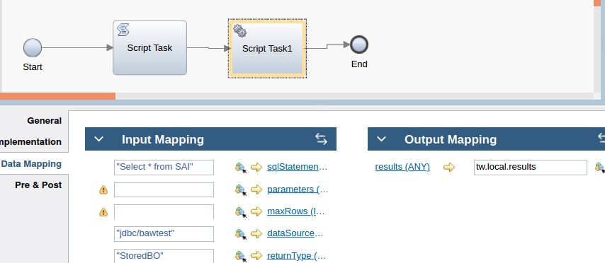

tw.local.sql="call SELECTSAI(?,?,?,?,?)";
tw.local.params= new tw.object.listOf.SQLParameter();
tw.local.params[0]= new tw.object.SQLParameter();
tw.local.params[0].type="INTEGER";
tw.local.params[0].mode="IN";
tw.local.params[0].value=tw.local.stored.empid;

tw.local.params[1]= new tw.object.SQLParameter();
tw.local.params[1].type="VARCHAR";
tw.local.params[1].mode="IN";
tw.local.params[1].value=tw.local.stored.empName;

tw.local.params[2]= new tw.object.SQLParameter();
tw.local.params[2].type="VARCHAR";
tw.local.params[2].mode="IN";
tw.local.params[2].value=tw.local.stored.prof;

tw.local.params[3]= new tw.object.SQLParameter();
tw.local.params[3].type="INTEGER";
tw.local.params[3].mode="IN";
tw.local.params[3].value=tw.local.stored.salary;

tw.local.params[4]= new tw.object.SQLParameter();
tw.local.params[4].type="VARCHAR";
tw.local.params[4].mode="IN";
tw.local.params[4].value=tw.local.stored.deptNo;

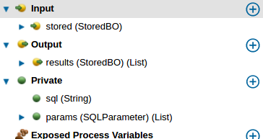

20..select Transaction

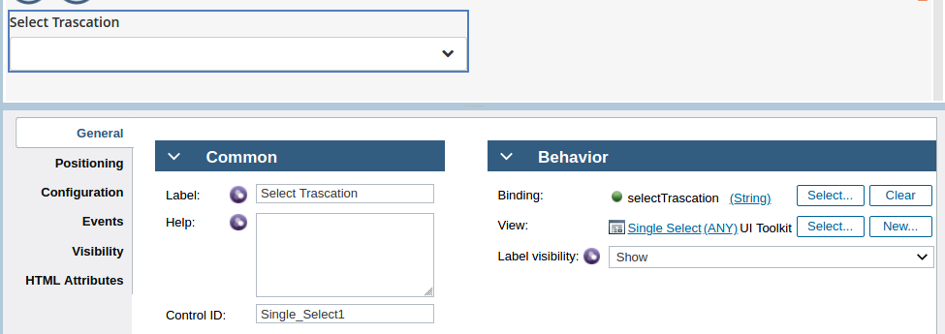

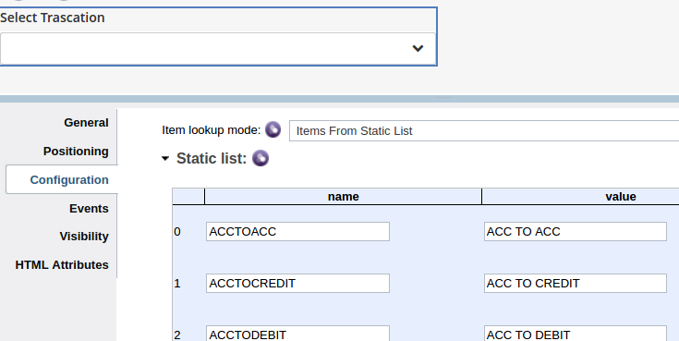

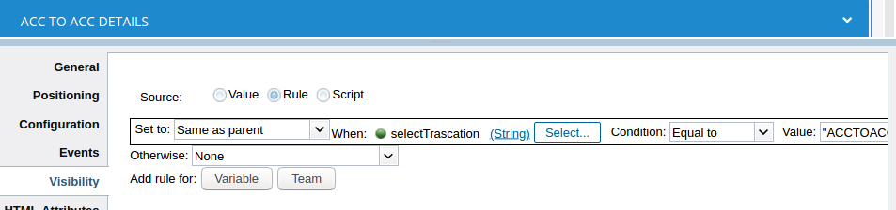

21..On clicking image,it should display another window

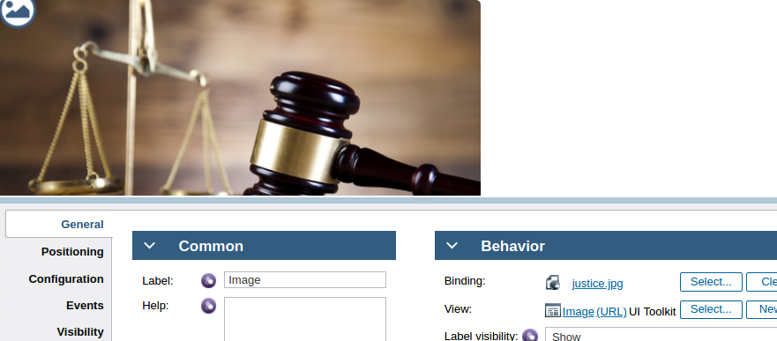
var getdataBtn=document.querySelector("[data-viewid='Image1']");
console.log("btn",getdataBtn);
getdataBtn.onclick=function(){
window.open(" https://192.168.3.142:9444/teamworks/executecf?processApp=CMBH&serviceName=Home%20Page&branchID=2063.9d674feb-33ad-4daf-b3dc-513b3355dccf");
}

22.Play Button

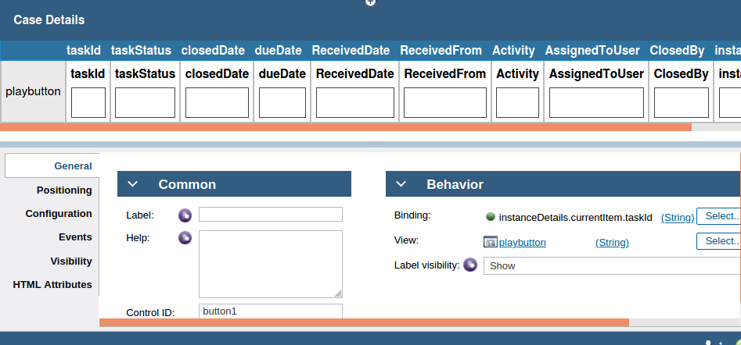

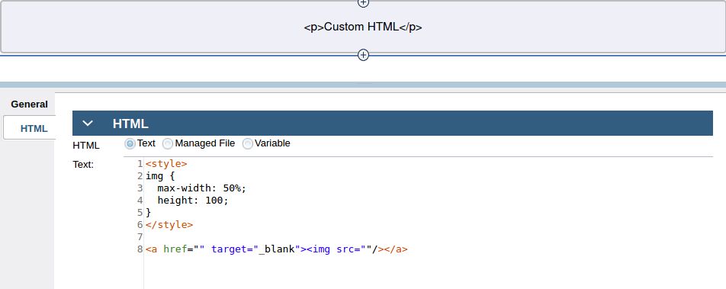

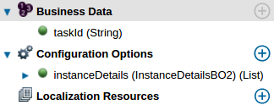

Ajax code for play button

var list = this.context.options.instanceDetails.get("value");

console.log("list",list);

var n=list.items.length;

console.log("n",n);

var i;var taskId=[];var id1=[];

var task=[];

var id=this.context.binding.get("value");

//for(i=0;i<n;i++)
//{
//taskId[i]=list.items[i].taskId;

taskId=id;

console.log("taskId",taskId);
console.log("in start CV",taskId);

var taskurl="https://192.168.3.142:9444/teamworks/process.lsw?zWorkflowState=1&zTaskId="+taskId+"&zResetContext=true";

var img=dojo.query("img",this.context.element)[0];

var link=dojo.query("a",this.context.element)[0];

console.log("taskurl",taskurl);

var imgUrl=com_ibm_bpm_coach.getManagedAssetUrl("play1.jpg",com_ibm_bpm_coach.assetType_WEB);

//dojo.setAttr(link,"href",url);
//dojo.setAttr(img,"src",imgUrl);

console.log("link",link);
console.log("img",img);

dojo.setAttr(link,"href", taskurl);
dojo.setAttr(img,"src", imgUrl);

//}

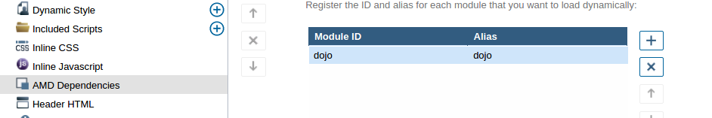

AMD Dependencies

23..Start Process By Service

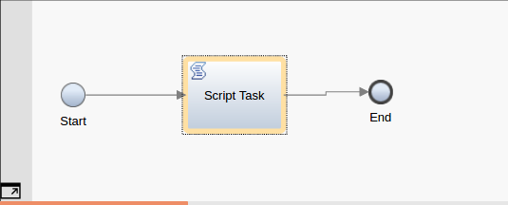

var rand=Math.random();
var uniqNo=rand*1000*10000*10;
rand=Math.floor(uniqNo);

var bpmrefNumber= 'ccms_'+rand;
tw.local.bpmrefNumber=bpmrefNumber;
var username=tw.system.user.name;

var map=new tw.object.Map();

map.put("bpmrefNumber",bpmrefNumber);
tw.system.startProcessByName("ccms process",map);

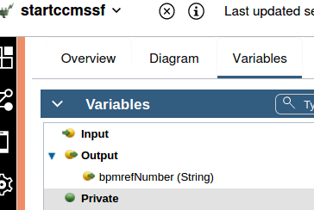

24..Delete Service

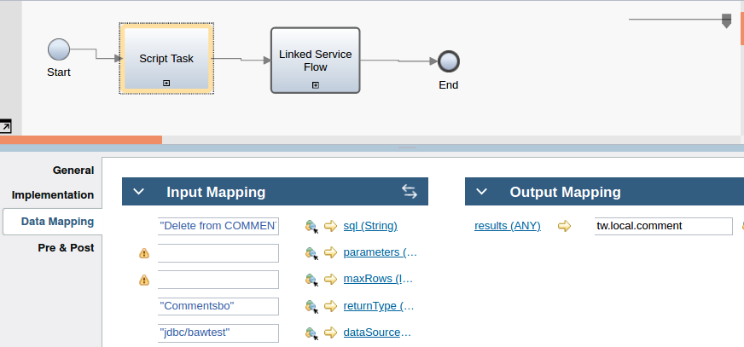

"Delete from COMMENTCHEQUE where commentid='"+tw.local.commentid+"'"

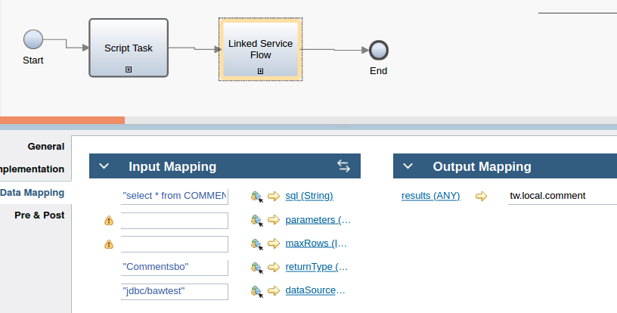

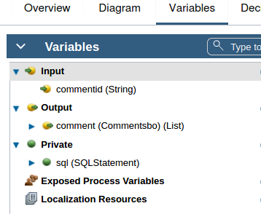

25..Converting two list to bo

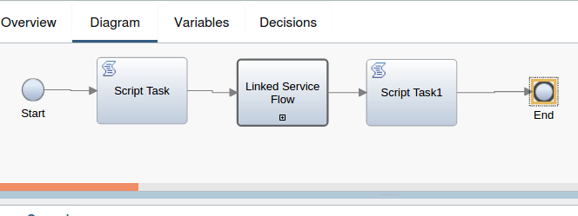

Script: tw.local.sqlquery=[]

tw.local.sqlquery[0]={}
tw.local.sqlquery[0].sql="SELECT*FROM oddrop";

tw.local.sqlquery[1]={}
tw.local.sqlquery[1].sql="select *FROM audit1";

Linked Service:

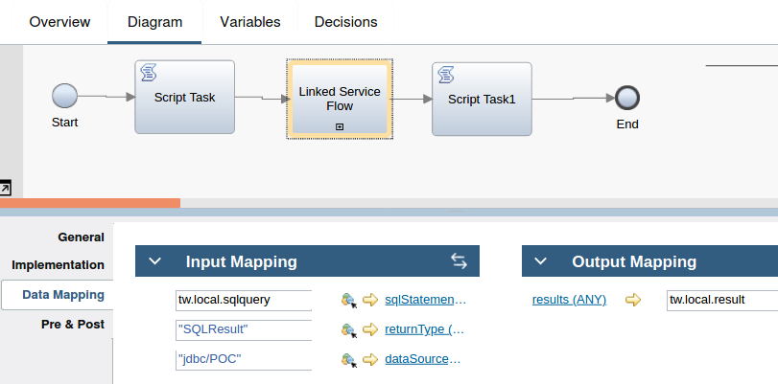

Script task1:

for (var i=0; i<tw.local.result[0].rows.listLength;i++)
{

tw.local.Oddrop[i]={ };
tw.local.Oddrop[i].AccountStatus=tw.local.result[0].rows[i].indexedMap.ACCOUNTSTATUS;
tw.local.Oddrop[i].HoldName=tw.local.result[0].rows[i].indexedMap.HOLDNAME;
tw.local.Oddrop[i].IsBlocked=tw.local.result[0].rows[i].indexedMap.ISBLOCKED;
tw.local.Oddrop[i].TotalBalance=tw.local.result[0].rows[i].indexedMap.TOTALBALANCE

}
for (var j=0; j<tw.local.result[1].rows.listLength;j++)
{

tw.local.audit[j]={ };
tw.local.audit[j].ActionedBy=tw.local.result[1].rows[j].indexedMap.ACTIONEDBY;
tw.local.audit[j].CurrentAction=tw.local.result[1].rows[j].indexedMap.CURRENTACTION;
tw.local.audit[j].LogIn=tw.local.result[1].rows[j].indexedMap.LOGIN;
tw.local.audit[j].LogOut=tw.local.result[1].rows[j].indexedMap.LOGOUT;

}

tw.local.convertedBo={}
tw.local.convertedBo.AccountStatus=tw.local.Oddrop[0].AccountStatus;
tw.local.convertedBo.HoldName=tw.local.Oddrop[0].HoldName;
tw.local.convertedBo.IsBlocked=tw.local.Oddrop[0].IsBlocked;
tw.local.convertedBo.TotalBalance=tw.local.Oddrop[0].TotalBalance;

tw.local.convertedBo.ActionedBy=tw.local.audit[1].ActionedBy;
tw.local.convertedBo.CurrentAction=tw.local.audit[1].CurrentAction;
tw.local.convertedBo.LogIn=tw.local.audit[1].LogIn;
tw.local.convertedBo.LogOut=tw.local.audit[1].LogOut;

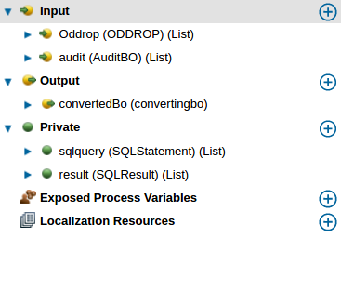

26....Team Filter

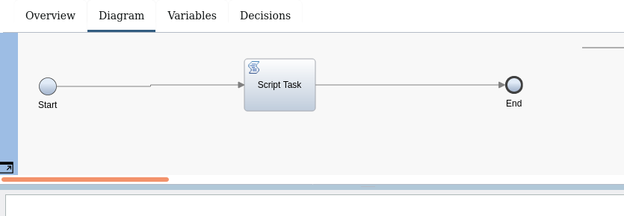

var filteredTeam = new tw.object.Team();
filteredTeam.members = new tw.object.listOf.String();

function addToFilteredTeam(Maker,Checker){
if(Maker){
var tmUsers = new tw.object.Team();
tmUsers.members = new tw.object.listOf.String();
for(var idx = 0; idx < Maker.length; idx++){
if(Checker)
{
tmUsers.members.insertIntoList(tmUsers.members.listLength,Maker[idx].name);
}else{
if(tw.system.org.findUserByName(tw.local.previousMaker).name != Maker[idx].name)
{
tmUsers.members.insertIntoList(tmUsers.members.listLength,Maker[idx].name);
}
}
}
tw.local.filteredTeam = tmUsers;
}
}
addToFilteredTeam(tw.system.org.findTeamByName(String("Maker")).allUsers,false)
if(tw.local.filteredTeam.members.listLength ==0)
{
addToFilteredTeam(tw.system.org.findTeamByName(String("Checker")).allUsers,true)
}

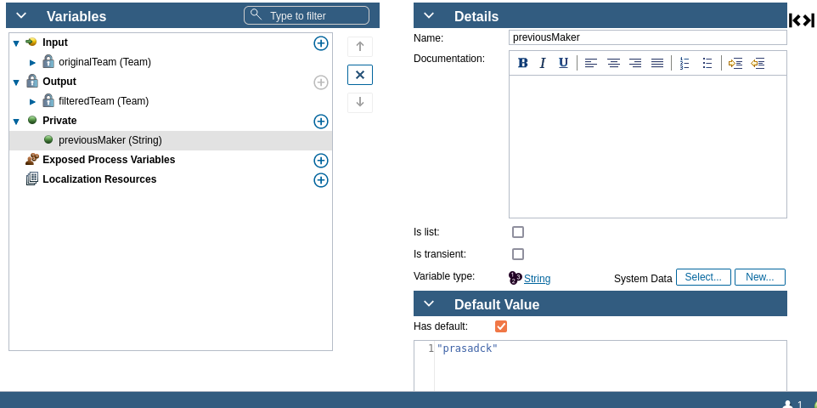

27...Resub queue

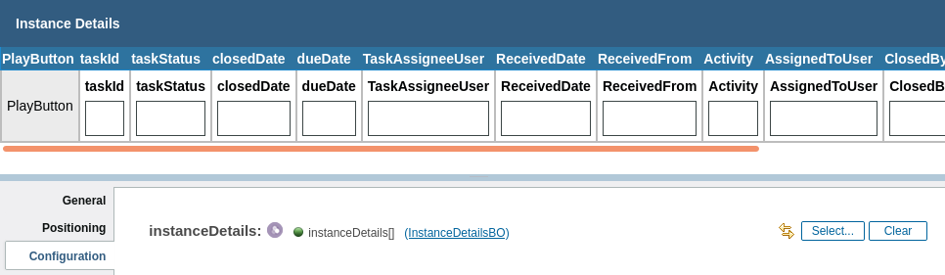

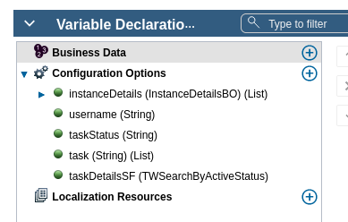

Tw Search By Active status service

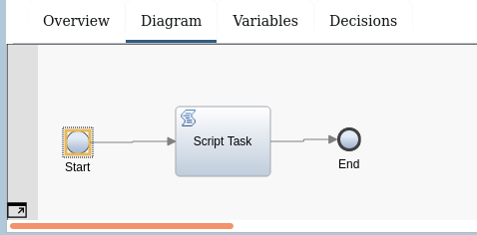

var search = new TWSearch();

var instaceid=new TWSearchColumn();
instaceid.type = TWSearchColumn.Types.ProcessInstance;
instaceid.name = TWSearchColumn.ProcessInstanceColumns.ID;

var Activity = new TWSearchColumn();
Activity.type = TWSearchColumn.Types.Task;
Activity.name = TWSearchColumn.TaskColumns.Activity;

var AssignedToUser = new TWSearchColumn();
AssignedToUser.type = TWSearchColumn.Types.Task;
AssignedToUser.name = TWSearchColumn.TaskColumns.AssignedToUser;

var ClosedBy = new TWSearchColumn();
ClosedBy.type = TWSearchColumn.Types.Task;
ClosedBy.name = TWSearchColumn.TaskColumns.ClosedBy;

var colTaskId = new TWSearchColumn();
colTaskId.type = TWSearchColumn.Types.Task;
colTaskId.name = TWSearchColumn.TaskColumns.ID;

var colTaskStatus = new TWSearchColumn();
colTaskStatus.type = TWSearchColumn.Types.Task;
colTaskStatus.name = TWSearchColumn.TaskColumns.Status;

var colClosedDateTime = new TWSearchColumn();
colClosedDateTime.type = TWSearchColumn.Types.Task;
colClosedDateTime.name = TWSearchColumn.TaskColumns.ClosedDate;

var colDueDateTime = new TWSearchColumn();
colDueDateTime.type = TWSearchColumn.Types.Task;
colDueDateTime.name = TWSearchColumn.TaskColumns.DueDate;

var colReceivedDateTime = new TWSearchColumn();
colReceivedDateTime.type = TWSearchColumn.Types.Task;
colReceivedDateTime.name = TWSearchColumn.TaskColumns.ReceivedDate;

var colReceivedFrom = new TWSearchColumn();
colReceivedFrom.type = TWSearchColumn.Types.Task;
colReceivedFrom.name = TWSearchColumn.TaskColumns.ReceivedFrom;

search.columns=new Array(Activity,AssignedToUser,ClosedBy,colTaskId,
colTaskStatus,colClosedDateTime,colDueDateTime,colReceivedDateTime,colReceivedFrom,instaceid);

var condInstanceName = new TWSearchCondition;
condInstanceName.column = colTaskStatus;
condInstanceName.operator = TWSearchCondition.Operations.StartsWith;
condInstanceName.value = ""+tw.local.taskstatus+"";
//2
var conduserName = new TWSearchCondition;
conduserName.column = AssignedToUser;
conduserName.operator = TWSearchCondition.Operations.StartsWith;
conduserName.value = ""+tw.local.username+"";

var conditions = new Array(condInstanceName,conduserName);
search.conditions = conditions;

var orderInstanceId = new TWSearchOrdering();
orderInstanceId.column = colTaskStatus,conduserName;
orderInstanceId.order = TWSearchOrdering.Orders.Ascending;
search.orderBy = new Array(orderInstanceId);
search.organizedBy = TWSearch.OrganizeByTypes.Task;

var results = search.execute();
tw.local.instanceDetails3=new tw.object.listOf.InstanceDetailsBO();
for ( var i = 0 ; i < results.rows.length ; i++ ) {

var row=results.rows[i];
tw.local.instanceDetails3[i]=new tw.object.InstanceDetailsBO();
tw.local.instanceDetails3[i].Activity=row.values[0];
tw.local.instanceDetails3[i].AssignedToUser=row.values[1];
tw.local.instanceDetails3[i].ClosedBy=row.values[2];
tw.local.instanceDetails3[i].taskId=row.values[3].toString();
tw.local.instanceDetails3[i].taskStatus=row.values[4].toString();
tw.local.instanceDetails3[i].closedDate=row.values[5];
tw.local.instanceDetails3[i].dueDate=row.values[6];
tw.local.instanceDetails3[i].ReceivedDate=row.values[7];
tw.local.instanceDetails3[i].ReceivedFrom=row.values[8];
tw.local.instanceDetails3[i].instanceId=row.values[9].toString();
}

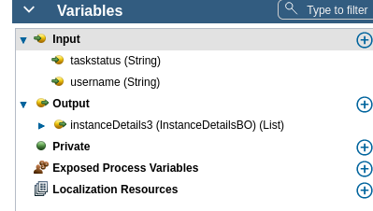

Ajax call for resubqueue( inlinejavascript)

1) inline java script

var select=function()
{

var username=this.context.options.username.get("value");

var taskstatus=this.context.options.taskStatus.get("value");

console.log("username",username,"taskStatus",taskstatus);

var input={'username': username,'taskstatus':taskstatus};

var args={

params:JSON.stringify(input),

load:function(view){

console.log("data",view);

this.context.options.instanceDetails.set("value",view.instanceDetails3.items);

}.bind(this),

error:function(e){

console.log(e);

}.bind(this)

}

this.context.options.taskDetailsSF(args);

}.bind(this);

2) load::: select();

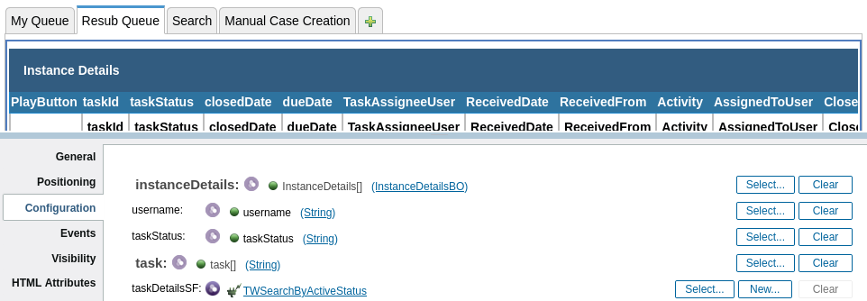

28..... Manual case creation

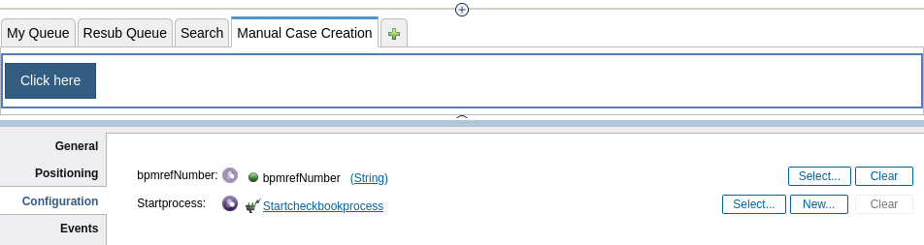

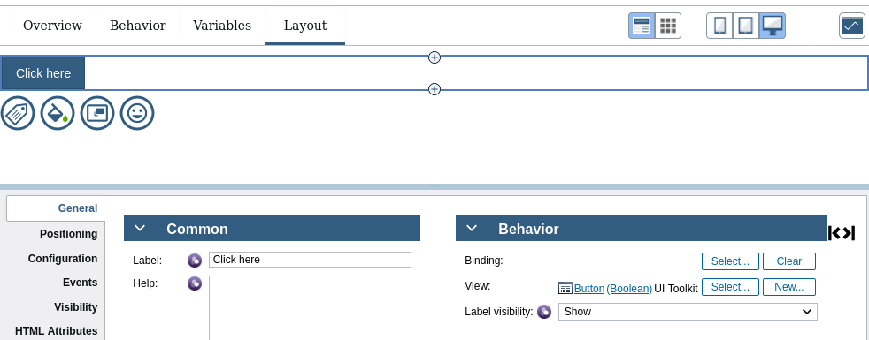

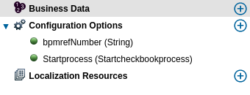

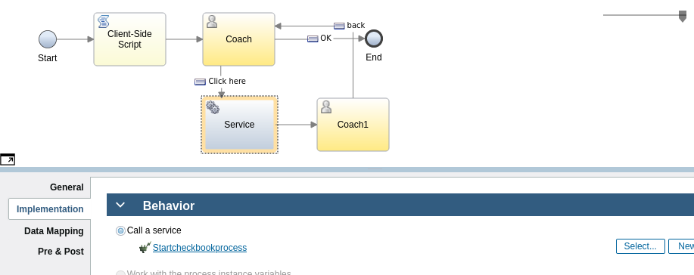

Coach 1....

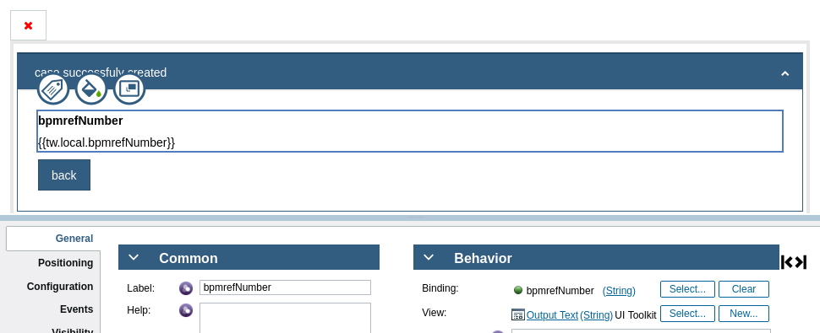

29..... Search

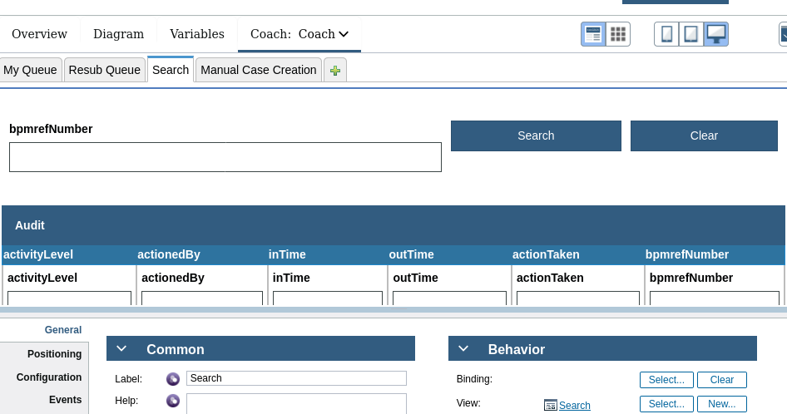

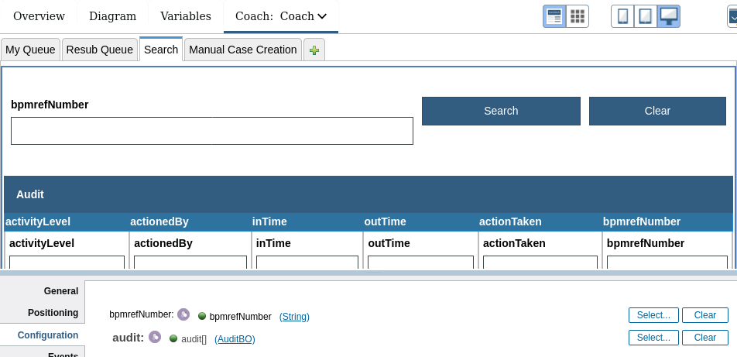

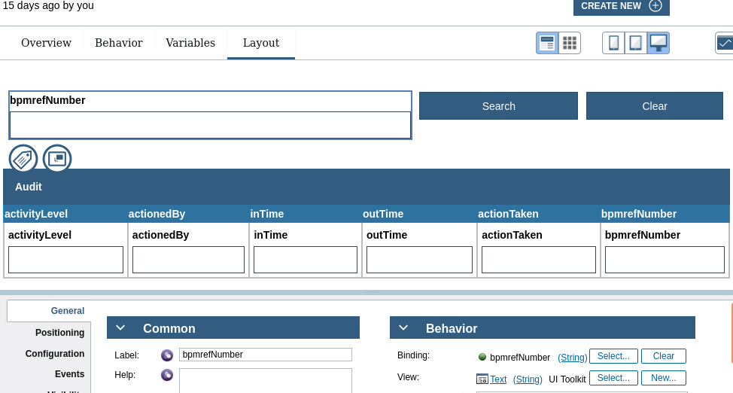

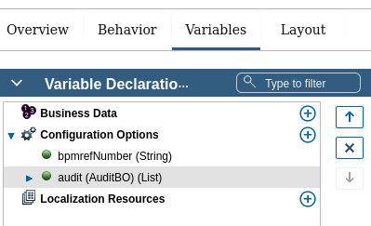

28... My Queue

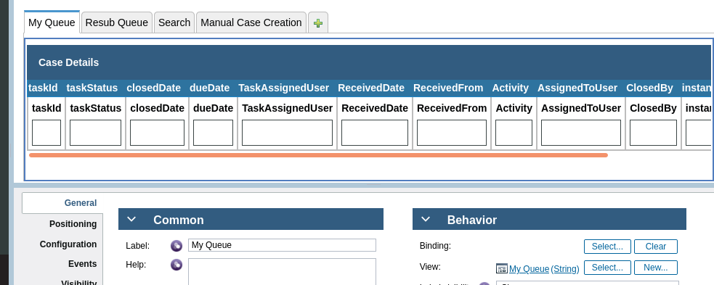

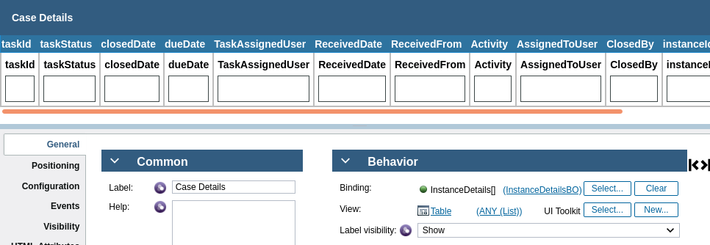

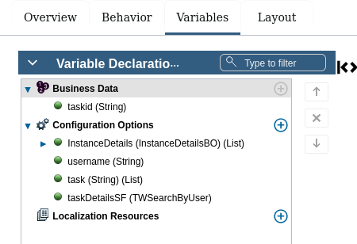

TwSearch By User Sevice

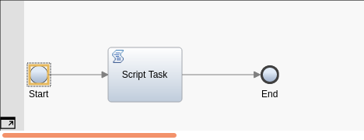

var search = new TWSearch();

var instaceid=new TWSearchColumn();
instaceid.type = TWSearchColumn.Types.ProcessInstance;
instaceid.name = TWSearchColumn.ProcessInstanceColumns.ID;

var Activity = new TWSearchColumn();
Activity.type = TWSearchColumn.Types.Task;
Activity.name = TWSearchColumn.TaskColumns.Activity;

var AssignedToUser = new TWSearchColumn();
AssignedToUser.type = TWSearchColumn.Types.Task;
AssignedToUser.name = TWSearchColumn.TaskColumns.AssignedToUser;

var ClosedBy = new TWSearchColumn();
ClosedBy.type = TWSearchColumn.Types.Task;
ClosedBy.name = TWSearchColumn.TaskColumns.ClosedBy;

var colTaskId = new TWSearchColumn();
colTaskId.type = TWSearchColumn.Types.Task;
colTaskId.name = TWSearchColumn.TaskColumns.ID;

var colTaskStatus = new TWSearchColumn();
colTaskStatus.type = TWSearchColumn.Types.Task;
colTaskStatus.name = TWSearchColumn.TaskColumns.Status;

var colClosedDateTime = new TWSearchColumn();
colClosedDateTime.type = TWSearchColumn.Types.Task;
colClosedDateTime.name = TWSearchColumn.TaskColumns.ClosedDate;

var colDueDateTime = new TWSearchColumn();
colDueDateTime.type = TWSearchColumn.Types.Task;
colDueDateTime.name = TWSearchColumn.TaskColumns.DueDate;

var colReceivedDateTime = new TWSearchColumn();
colReceivedDateTime.type = TWSearchColumn.Types.Task;
colReceivedDateTime.name = TWSearchColumn.TaskColumns.ReceivedDate;

var colReceivedFrom = new TWSearchColumn();
colReceivedFrom.type = TWSearchColumn.Types.Task;
colReceivedFrom.name = TWSearchColumn.TaskColumns.ReceivedFrom;

search.columns=new Array(Activity,AssignedToUser,ClosedBy,colTaskId,
colTaskStatus,colClosedDateTime,colDueDateTime,colReceivedDateTime,colReceivedFrom,instaceid);

var condInstanceName = new TWSearchCondition;
condInstanceName.column = AssignedToUser;
condInstanceName.operator = TWSearchCondition.Operations.StartsWith;
condInstanceName.value = ""+tw.local.username+"";

var conditions = new Array(condInstanceName);
search.conditions = conditions;

var orderInstanceId = new TWSearchOrdering();
orderInstanceId.column = AssignedToUser;
orderInstanceId.order = TWSearchOrdering.Orders.Ascending;
search.orderBy = new Array(orderInstanceId);
search.organizedBy = TWSearch.OrganizeByTypes.Task;

var results = search.execute();
tw.local.InstanceDetails=new tw.object.listOf.InstanceDetailsBO();
for ( var i = 0 ; i < results.rows.length ; i++ ) {

var row=results.rows[i];
tw.local.InstanceDetails[i]=new tw.object.InstanceDetailsBO();
tw.local.InstanceDetails[i].Activity=row.values[0];
tw.local.InstanceDetails[i].AssignedToUser=row.values[1];
tw.local.InstanceDetails[i].ClosedBy=row.values[2];
tw.local.InstanceDetails[i].taskId=row.values[3].toString();
tw.local.InstanceDetails[i].taskStatus=row.values[4].toString();
tw.local.InstanceDetails[i].closedDate=row.values[5];
tw.local.InstanceDetails[i].dueDate=row.values[6];
tw.local.InstanceDetails[i].ReceivedDate=row.values[7];
tw.local.InstanceDetails[i].ReceivedFrom=row.values[8];
tw.local.InstanceDetails[i].instanceId=row.values[9].toString();

}

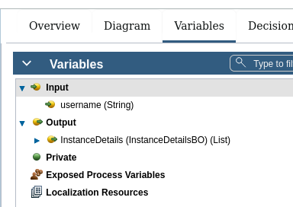

Ajax call for my queue cv

1) inline java script

var select=function()
{

var username=this.context.options.username.get("value");

console.log("username",username);

var input={'username': username};

var args={

params:JSON.stringify(input),

load:function(view){

console.log("data",view);

this.context.options.InstanceDetails.set("value",view.InstanceDetails.items);

}.bind(this),

error:function(e){

console.log(e);

}.bind(this)

}

this.context.options.taskDetailsSF(args);

}.bind(this);

2) load: select();

29..Stored Procedure for Selecting

create or replace NONEDITIONABLE PROCEDURE SEARCHSP
(
CCMSSEARCH OUT SYS_REFCURSOR
)AS
BEGIN
open CCMSSEARCH for
select * from CCMSSEARCH WHERE name=name OR licencenumber=licencenumber OR emiratesid=emiratesid OR passport=passport OR cif=cif ;
NULL;
END SEARCHSP;

30...Code for condition(if maker and checker tasks are there,if checker checks everything and any issues found it will send back to maker,,, for that we will use code in exclusive gate way)

take one variable btn with type boolean

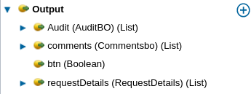

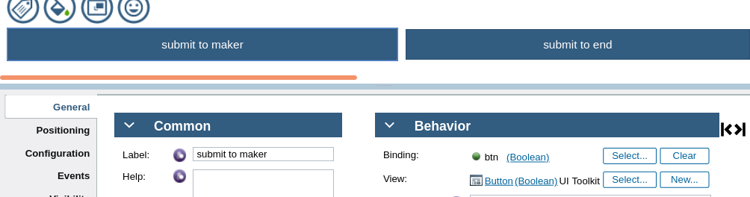

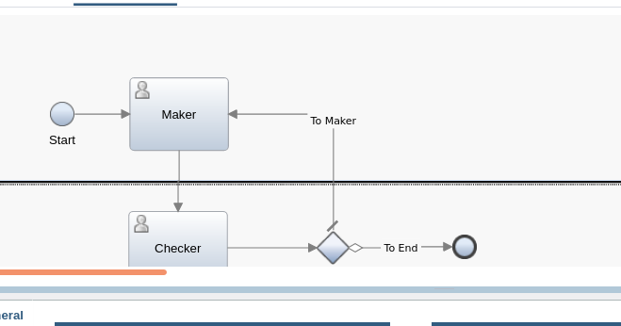

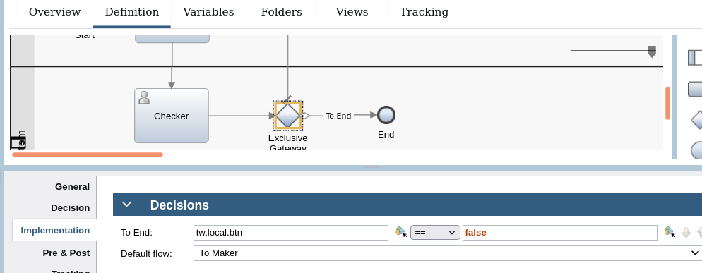

Practice..

tw.local.sql=new tw.object.sqlstatement();
tw.local.sql.sql=”insert into tablename values(?,?,?,?)”;
tw.local.sql.parameters=new tw.object.listof.sqlparameter();
tw.local.sql.parameter[0]=new tw.object.sqlparameter();
tw.local.sql.parameter[0].mode=”in”;
tw.local.sql.parameter[0].type=”integer”;
tw.local.sql.parameter[0].value=tw.local.boname.variablename;
tw.local.sql.parameter[1]=new tw.object.sqlparameter()
tw.local.sql.parameter[1].mode=”in”;
tw.local.sql.parameter[1].type=”varchar”;
tw.local.sql.parameter[1].value=tw.local.boname.variablename;

to create bo object

tw.local.boname={};...business object name;;
tw.local.comment={};
tw.local.comment.commentedbyuser=tw.system.user_fullname;
tw.local.comment.commenteddate=new date();
tw.local.comment.role=”maker”;......any role
tw.local.comment.bpmrefnum=tw.local.bpmrefnum;

var control id of variable=${control id of variable}.getText(); (every field has control id,we have take that variables control id and by that we have declare the variable)

var accnum=${accnum}.getText();
var custname=${custname}.getText();
if(accnum==”” && custname==””)
{
alert(“plz enter atleast one field”);
}

clear

var accnum=${accnum}.getText();
var custname=${custname}.getText();
if(accnum!=”” && custname!=””)
{
${accnum}.setText()==””;
${custname}.setText()==””;
}

Stored Procedure

create or replace procedure sample
(
tablename out sys_refcursor
)As
Begin
open tablename for select * from tablename where variable name1=variable name1 or variable name2=variable name2;
Null;
end sample

create or replace procedure sample
(
commentcheque out sys_refcursor
)As
Begin
open commentcheque for select * from commentcheque;(if we want to write where condition.... where name=name or age=age or salary=salary;)
null;
end sample;

create or replace procedure sample1
(
name in varchar2;
id in integer;
email in varchar2;
)As
Begin
insert into commentcheque(“name”,’id’,”email”)values(name,id,email);
Null;
end sample1;

Ajax for displaying hardcoded data

this.context.options.boname.get(“value”).set(“variable name”,”hghfg”);
this.context.options.empdetails.get(“value”).set(“name”,”harika”);
this.context.options.empdetails.get(“value”).set(“id”,”234”);
this.context.options.empdetails.get(“value”).set(“salary”,”7567”);

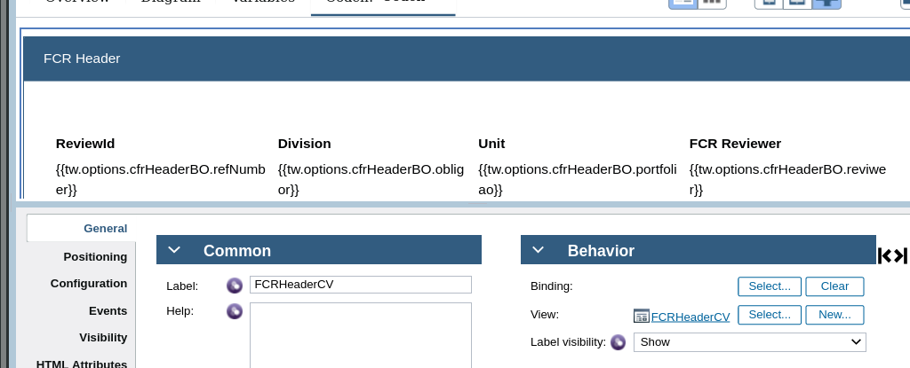

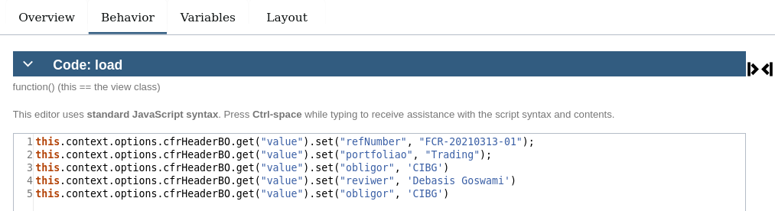

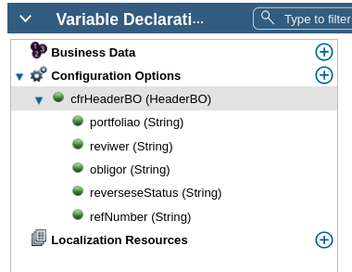

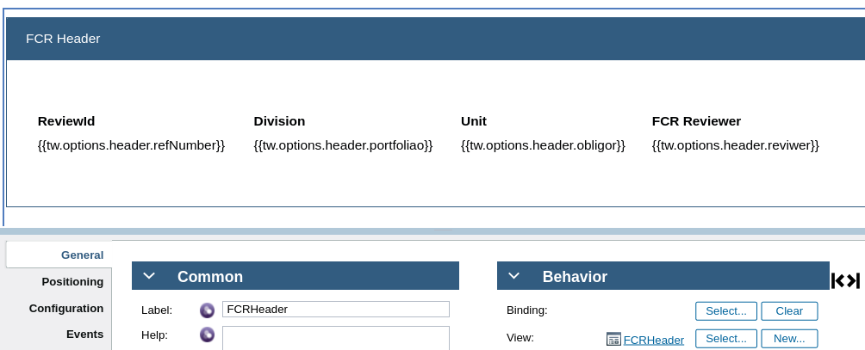

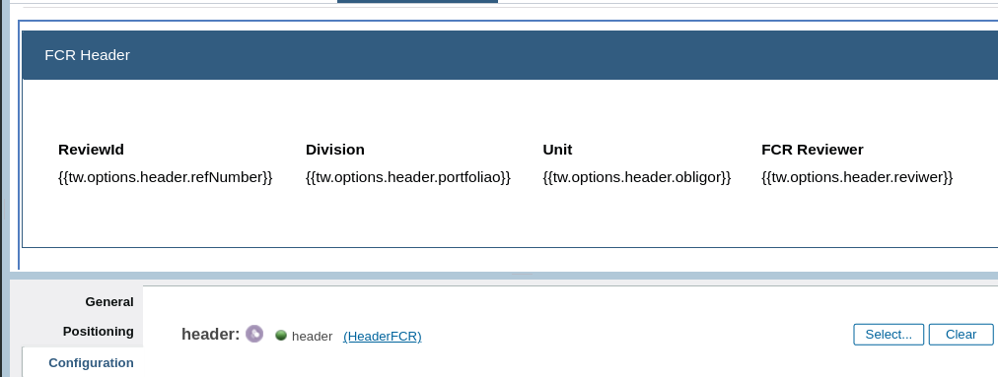

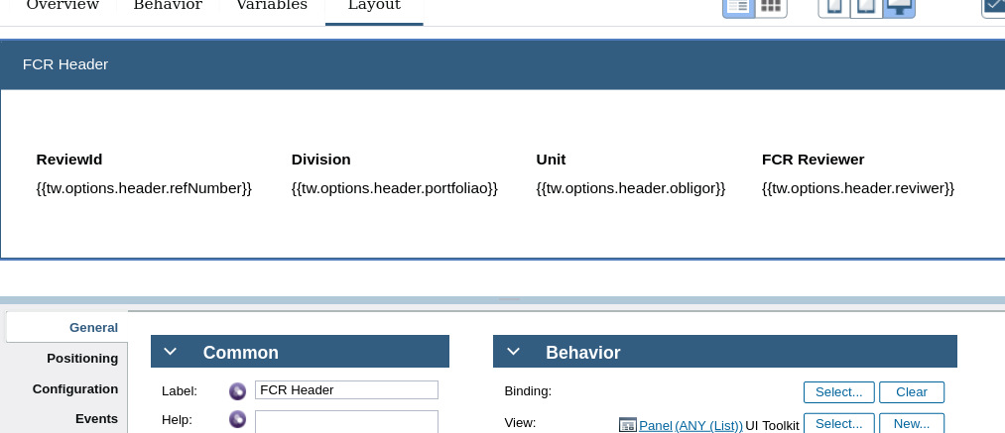

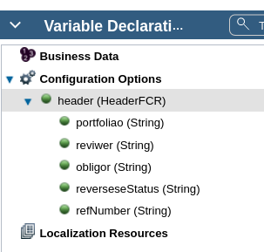

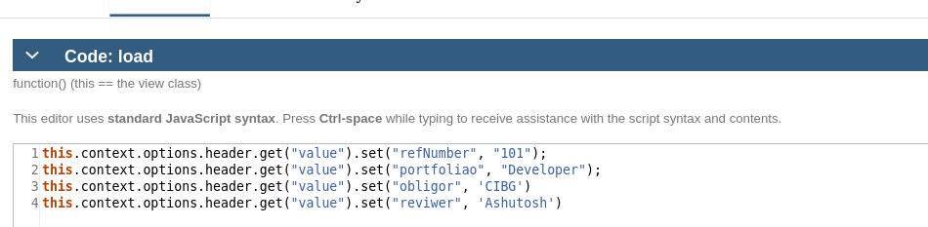

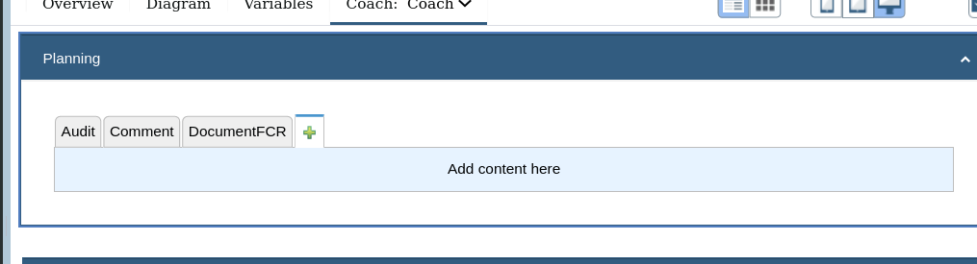

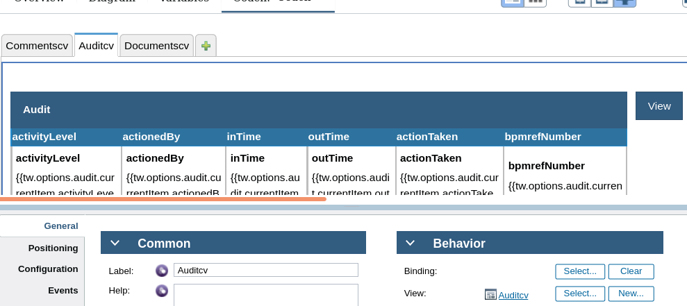

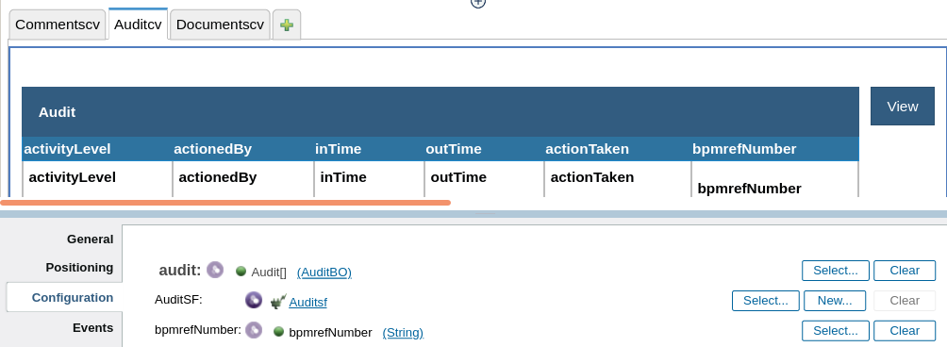

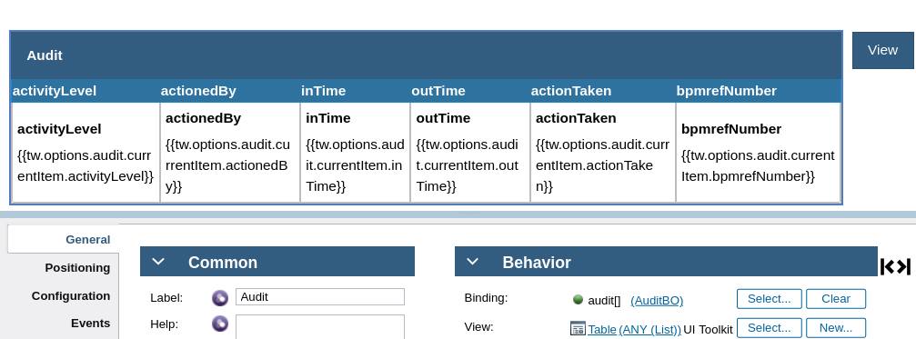

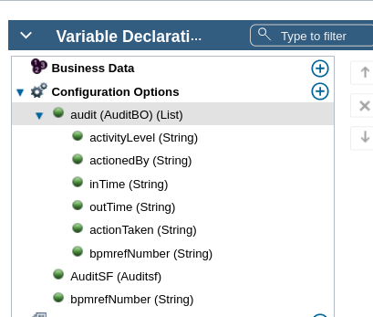

ajax..load

var getdataBtn=document.querySelector("[data-viewid='Button1audit']");
console.log("btn",getdataBtn);
getdataBtn.onclick=function(){
console.log("btn clicked");
var bpmref=this.context.options.bpmrefNumber.get("value");
var input={'bpmrefNumber' : bpmref};
var args={
params:JSON.stringify(input),
load:function(data)
{
console.log("data",data)
this.context.options.audit.set("value",data.Audit.items);
}.bind(this),

error:function(e){
console.log(e)
}.bind(this)

}
this.context.options.AuditSF(args);
}.bind(this);

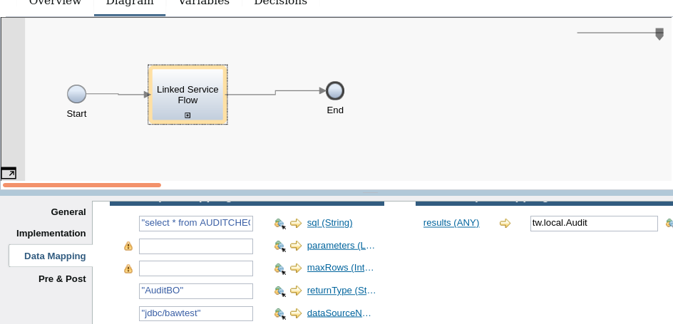

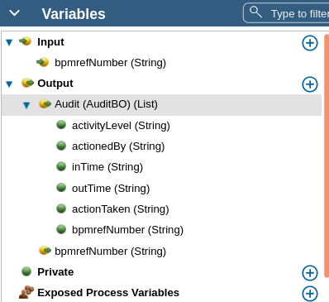

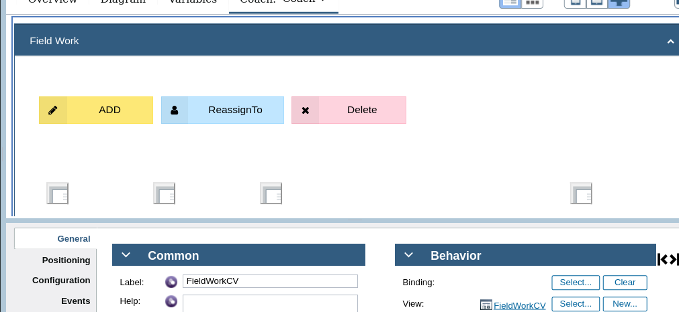

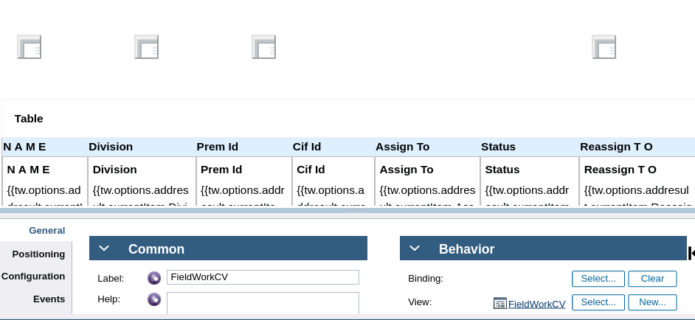

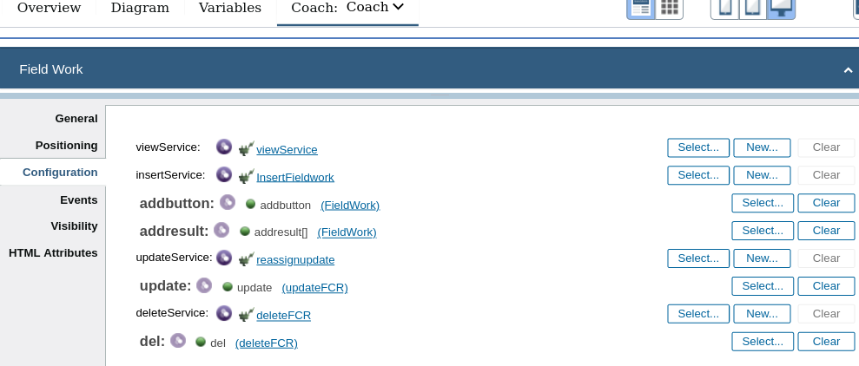
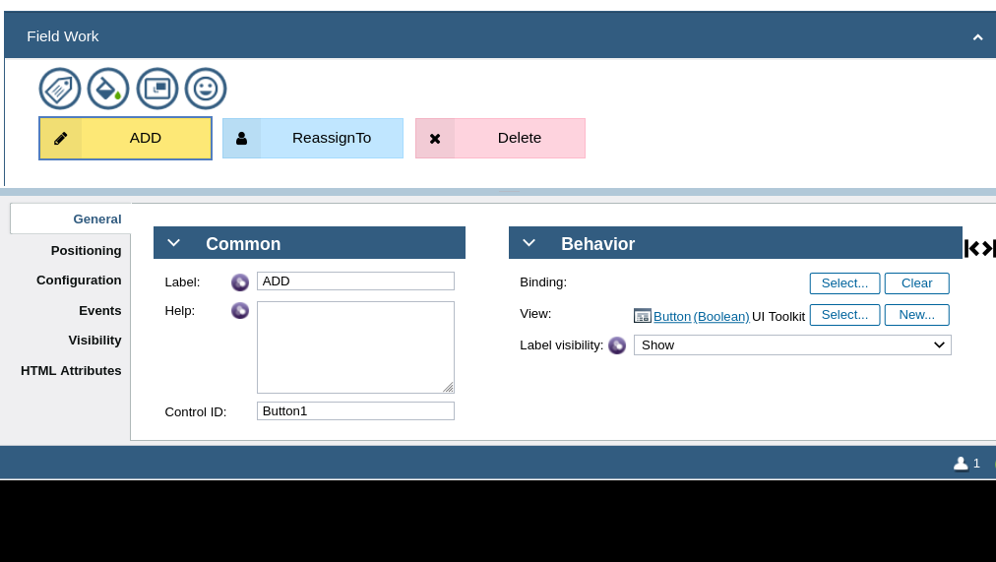

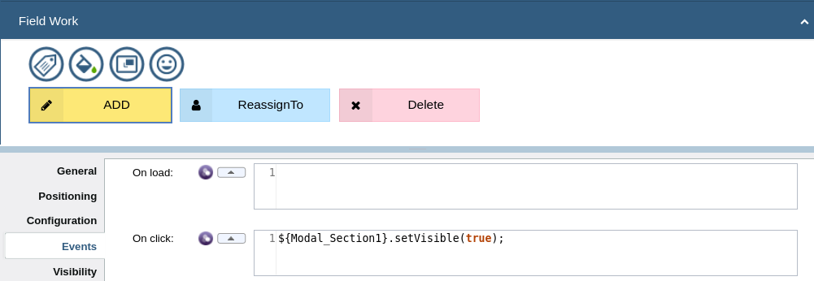

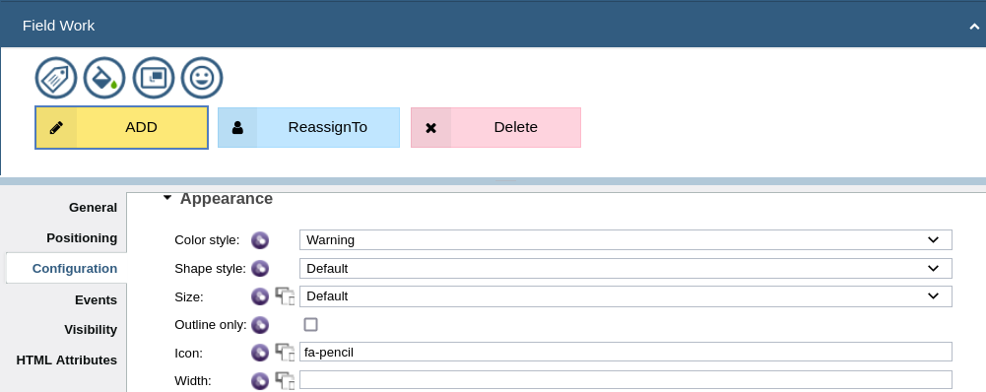

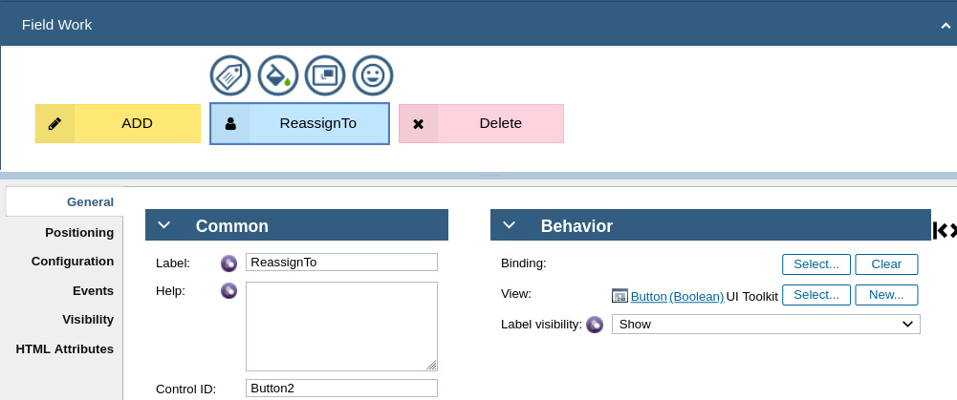

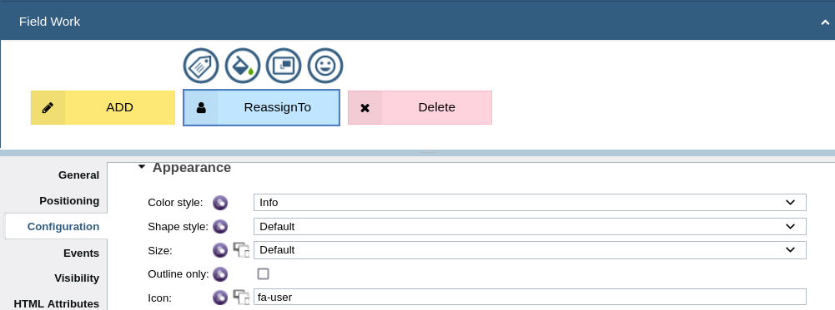

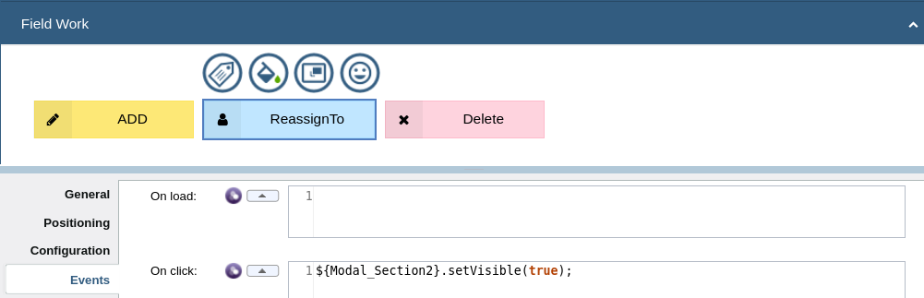

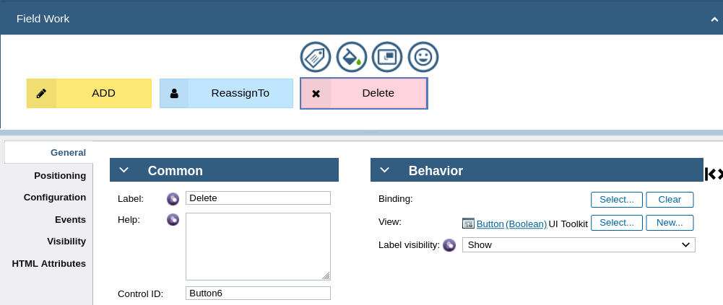

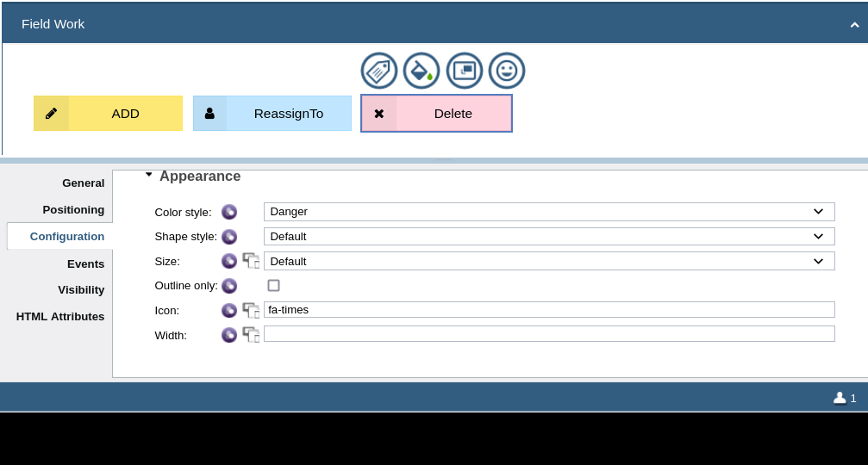

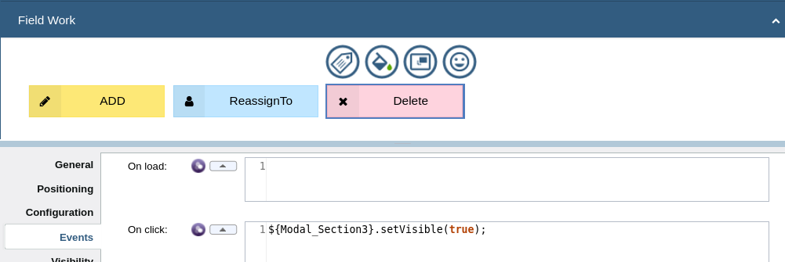

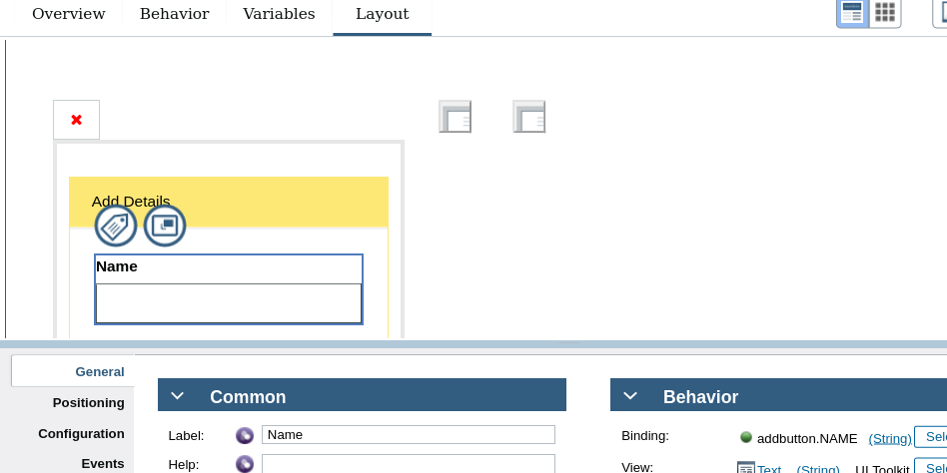

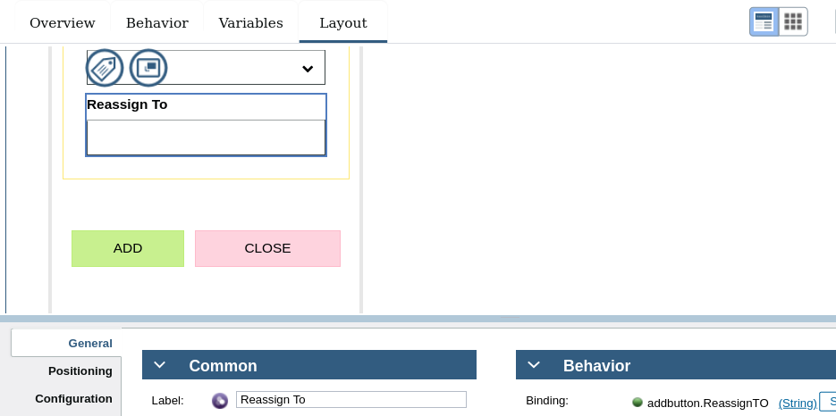

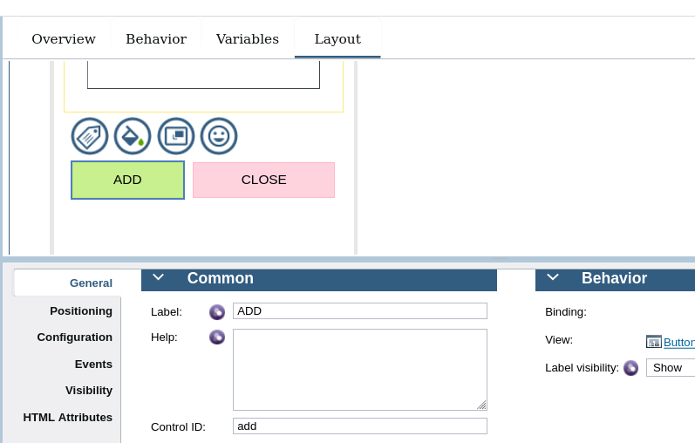

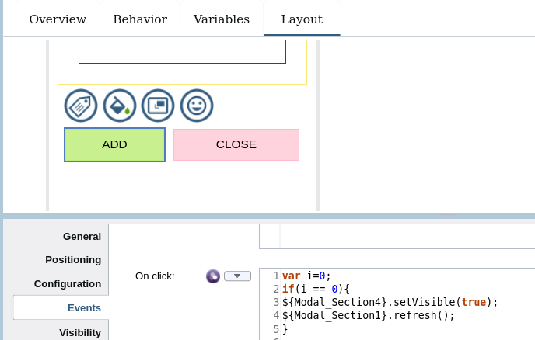

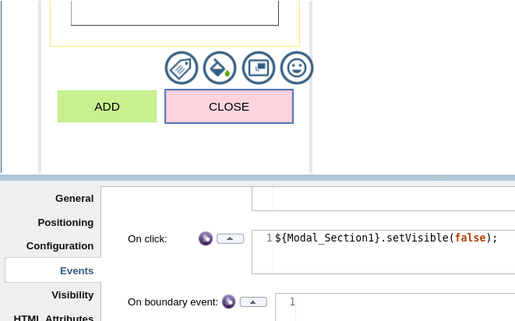

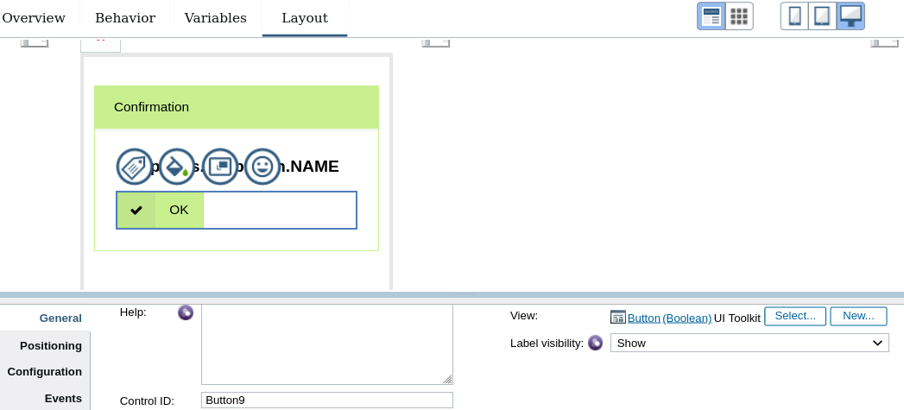

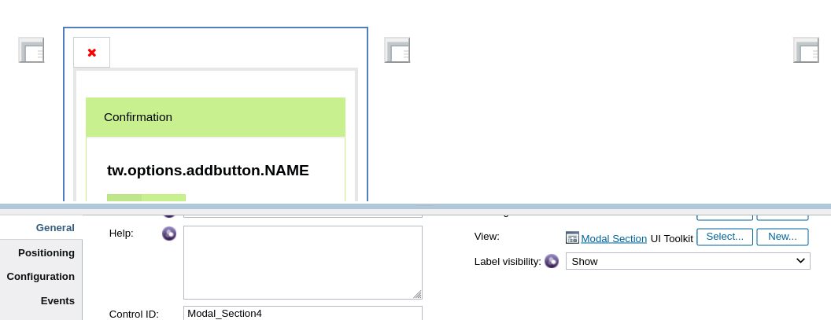

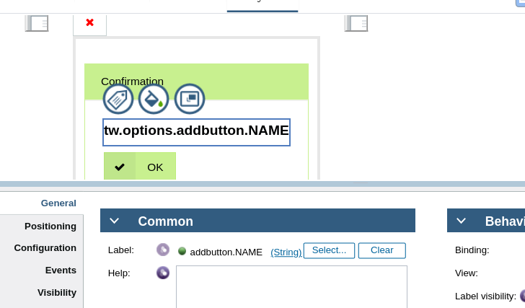

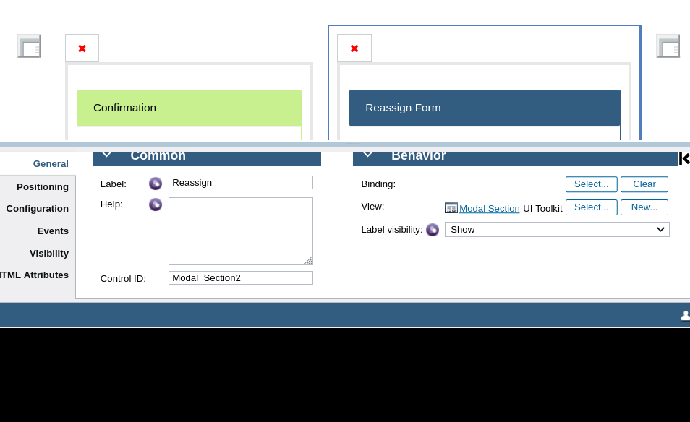

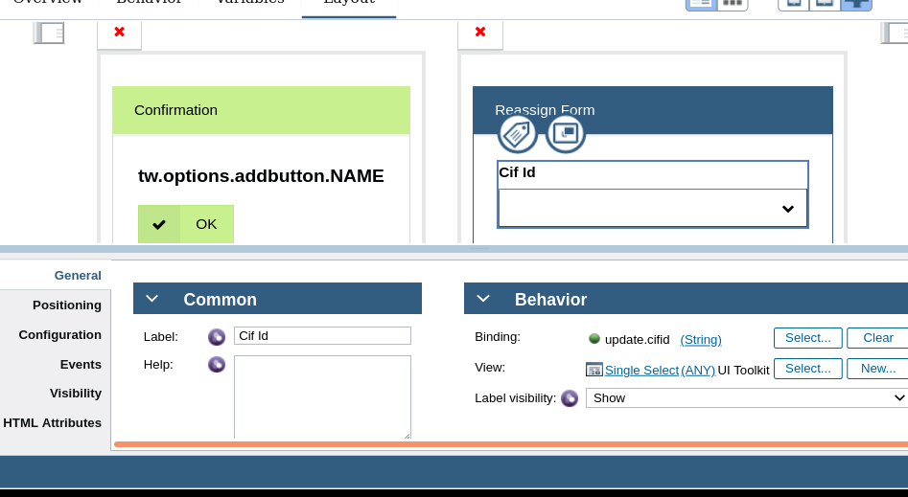

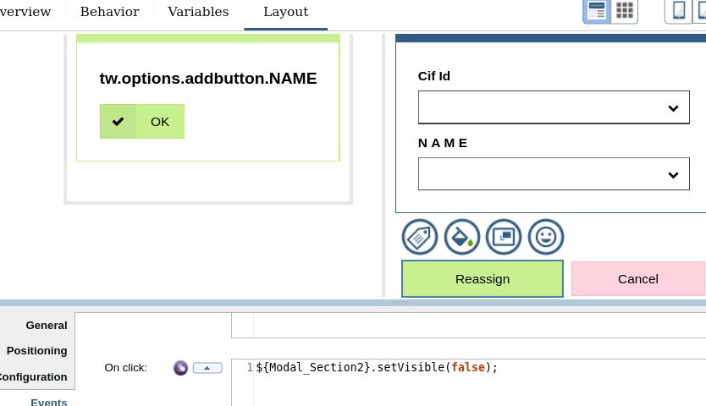

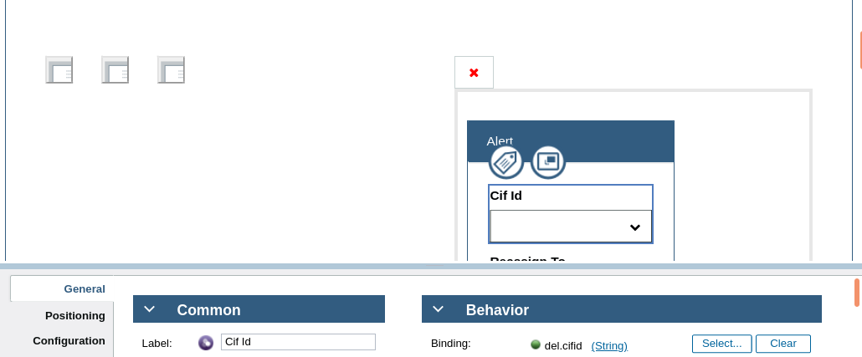

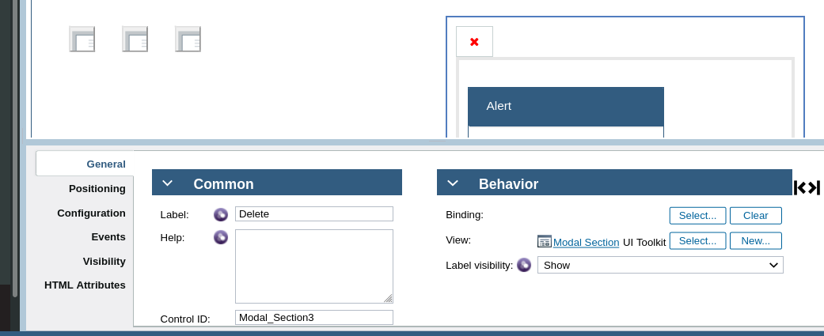

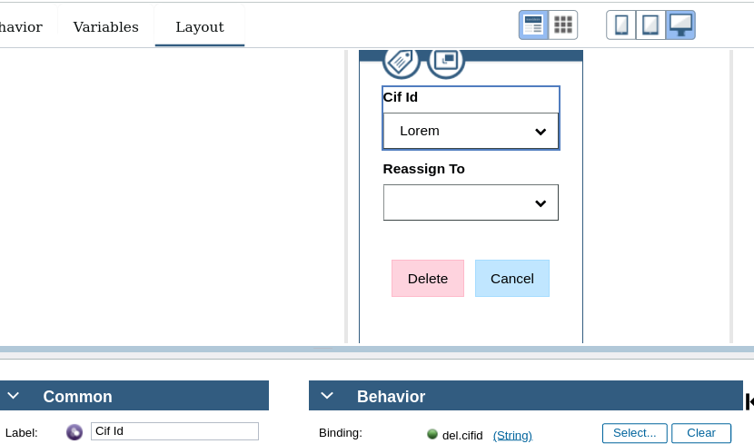

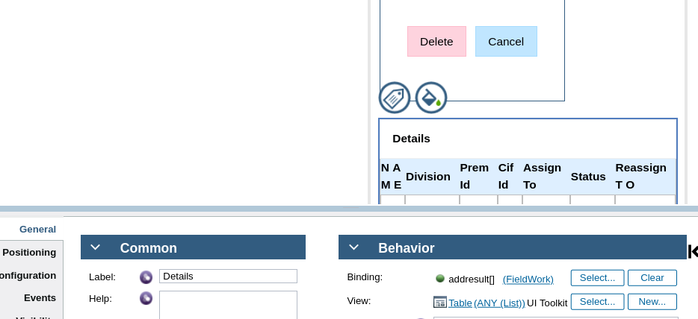

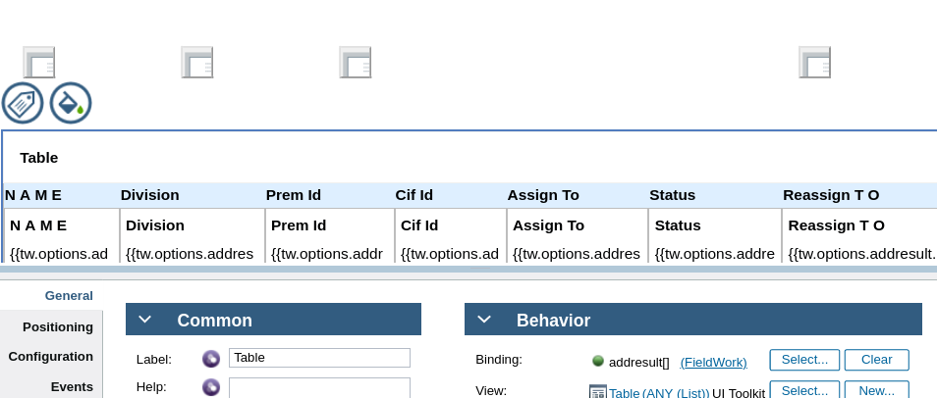

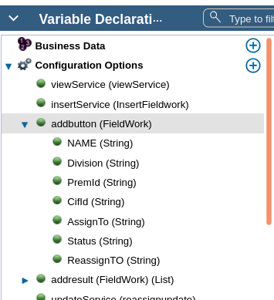

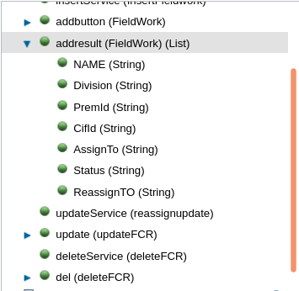

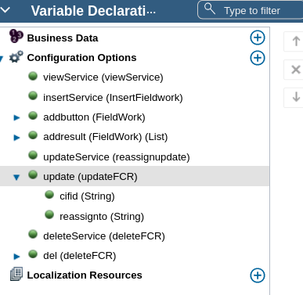

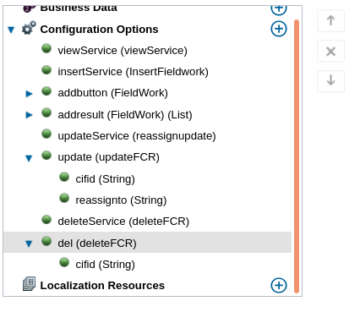

load....ajax code
view_data();

// Insert

var getdataBtn=document.querySelector("[data-viewid='add']");
console.log("btn",getdataBtn);
getdataBtn.onclick=function(){

var details={"Division":this.context.options.addbutton.get("value").get("Division")
,"NAME":this.context.options.addbutton.get("value").get("NAME")
,"PremId":this.context.options.addbutton.get("value").get("PremId")
,"CifId":this.context.options.addbutton.get("value").get("CifId")
,"AssignTo":this.context.options.addbutton.get("value").get("AssignTo")
,"Status":this.context.options.addbutton.get("value").get("Status")
,"ReassignTO":this.context.options.addbutton.get("value").get("ReassignTO")}

console.log("btn clicked");

console.log("values",details);

var input={'addbutton': details};

var args={
params:JSON.stringify(input),
load:function(view){
console.log("data",view);
this.context.options.addresult.set("value",view.addresult.items);
}.bind(this),
error:function(e){
console.log(e);
}.bind(this)
}
this.context.options.insertService(args);
}.bind(this)

// Update

var getdataBtn=document.querySelector("[data-viewid='Button4']");
console.log("btn",getdataBtn);
getdataBtn.onclick=function(){

var details={"cifid":this.context.options.update.get("value").get("cifid"),
"reassignto":this.context.options.update.get("value").get("reassignto")}

console.log("btn clicked");

console.log("values",details);

var input={'update': details};

var args={
params:JSON.stringify(input),
load:function(view){
console.log("data",view);
this.context.options.addresult.set("value",view.addresult.items);
}.bind(this),
error:function(e){
console.log(e);
}.bind(this)
}
this.context.options.updateService(args);
}.bind(this)

// delete

var getdataBtn=document.querySelector("[data-viewid='Button7']");
console.log("btn",getdataBtn);
getdataBtn.onclick=function(){

var details= {"cifid":this.context.options.del.get("value").get("cifid")}

console.log("btn clicked");

console.log("values",details);

var input={'del': details};

var args={
params:JSON.stringify(input),
load:function(view){
console.log("data",view);
this.context.options.addresult.set("value",view.addresult.items);
}.bind(this),
error:function(e){
console.log(e);
}.bind(this)
}
this.context.options.deleteService(args);
}.bind(this)

inline javascript...ajax code

var view_data=function(){

console.log("btn clicked");

var args={
params:{},
load:function(data)
{
console.log("data",data);
this.context.options.addresult.set("value",data.addresult.items);
}.bind(this),
error:function(e){
console.log(e);
}.bind(this)
}
this.context.options.viewService(args);
}.bind(this)

View Service...

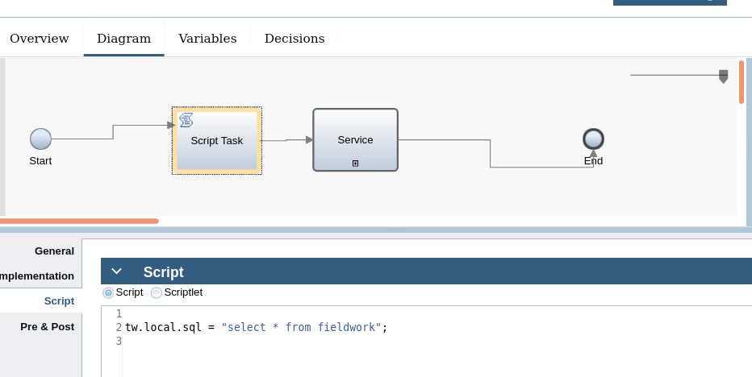

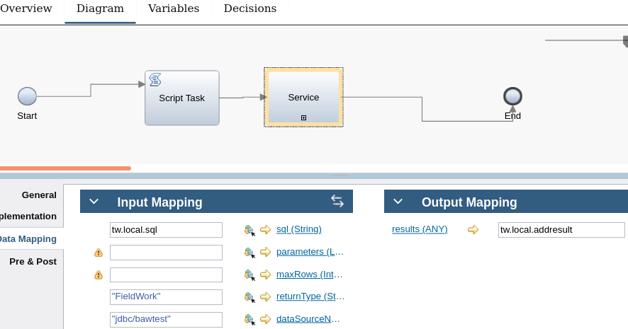

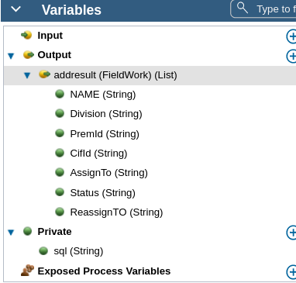

Update Service

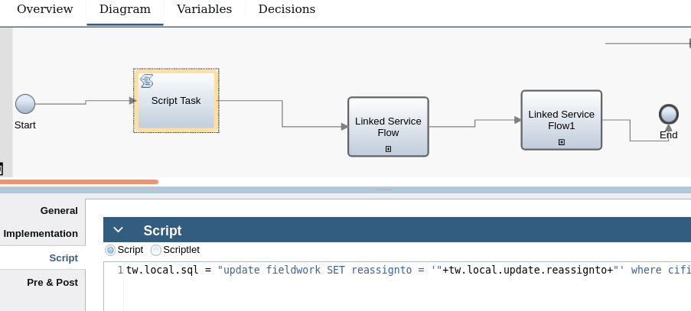

tw.local.sql = "update fieldwork SET reassignto = '"+tw.local.update.reassignto+"' where cifid = '"+tw.local.update.cifid+"'";

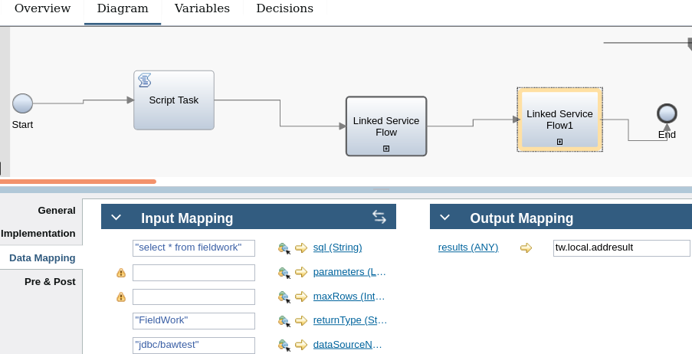

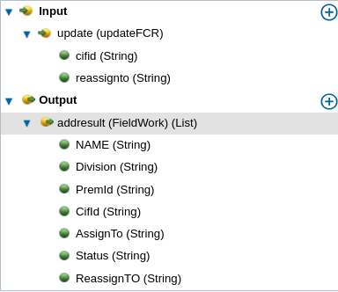

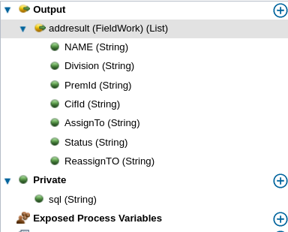

Delete service..

var getdataBtn=document.querySelector(“[data-viewid]”:’btn1’);
console.log(“btn”,getdatabtn);
getdatabtn.onclick=function(){
console.log(“btn is clicked”);
var id=this.contxt.options.comm.num.get(“value”);
var ref=this.contxt.options.comm.no.get(“value”);
var input={‘num:id’,’ref:no’}
var args={
params:json.stringify(input),
load:function(data)
{
console.log(“data”,data);
this.context.options.comm.set(“value”,data.comm.items);
}.bind(this),
error:function(e)
console.log(e);
}
}.bind(this)
this.context.options.sf(args);
}.bind(this);

Validations:...

var regID=/^[0-9]+$/;

if(tw.local.requestdetails.UserID==null || tw.local.requestdetails.UserID=="")

{

tw.system.coachValidation.addValidationError("tw.local.requestdetails.UserID","please enter value for UserID");

}

else if (regID.test(tw.local.requestdetails.UserID)== false)

{

tw.system.coachValidation.addValidationError("tw.local.requestdetails.UserID", "Please Enter Only in Numerical");

}

var regNAME=/^[a-zA-z]+$/;

if(tw.local.requestdetails.RequesterName==null || tw.local.requestdetails.RequesterName=="")

{

tw.system.coachValidation.addValidationError("tw.local.requestdetails.RequesterName","please enter a value for Requester Name");

}

else if (regNAME.test(tw.local.requestdetails.RequesterName)== false)

{

tw.system.coachValidation.addValidationError("tw.local.requestdetails.RequesterName", "Please Enter Only in [a-z (or) A-Z]");

}

var regaccountNumber=/^[0-9]+$/;

if(tw.local.requestdetails.AccountNo==null || tw.local.requestdetails.AccountNo=="")

{

tw.system.coachValidation.addValidationError("tw.local.requestdetails.AccountNo","please enter value for AccountNo");

}

else if (regID.test(tw.local.requestdetails.AccountNo)== false)

{

tw.system.coachValidation.addValidationError("tw.local.requestdetails.AccountNo", "Please Enter Only in Numerical");

}tw.local.readyToSubmit = tw.system.coachValidation.validationErrors.length==0;

var getdatabtn=document.queryselector(“[data-viewid=’btn1]”);
console.log(“btn”,getdatabtn);
getdatabtn.onclick=function(){
console.log(“btn is clicked”);
var id=this.context.options.idnum.get(“value”);
var ref=this.context.options.refno.get(“value”);
var input={‘idnum:id’,’refno:ref’};
var args={
params:json.stringify(input),
load:function(data)
{
console.log(“data”,data);
this.context.options.com.set(“value”,data.com.items);
}.bind(this),
error:function(e)
{
console.log(e);
}.bind(this)
}
this.context.options.sff(args);
}.bind(this)

var getdatabtn=document.queryselector(“[data-viewid=’btn2’]”);
console.log(“btn”,getdatabtn);
getdatabtn.onlclick=function(){
var input={};
var args={
params:json.stringify(input),
load:function(data)
{
this.context.options.output.set(“value”,data.output.items);
}.bind(this),
error:function(e)
{
console.log(e);
}.bind(this)
}
this.context.options.sf(args);
}.bind(this)

var getdatabtn=document.querySelector(“[data-viewid=’clearbtn’]”);
console.log(“btn”,getdatabtn);
getdatabtn.onclick=function(){
var temp=this.context.options.search.set(“value”,{});
var args={
params:json.stringify(input)
}
}.bind(this);

var getdatabtn=document.querySelector(“[data-viewid=’btn1’]”);
console.log(“btn”,getdatabtn);
getdatabtn.onclick=function(){
console.log(“btn is clicked);
var ref=this.context.options.refnumber.get(“value”);
var id=this.context.options.number.get(“value”);
var input={‘refnumber’:ref,’number’:id};
var args={
params:json.stringify(input),
load:function(data)
{
console.log(“data”,data);
this.context.options.com.set(“value”,data.com.items);
}.bind(this),
error:function(e)
{
console.log(e);
}.bind(this)
}
this.context.options.sf(args);
}.bind(this)

tw.local.comment={};
tw.local.comment.date=new date();
tw.local.comment.user=tw.system.user_fullname;
tw.local.comment.role=”mmm”;
tw.local.comment.refnumber=tw.local.refnum;
tw.local.comment.cm=tw.local.com1;

tw.local.sql=new tw.object.sqlstatement();
tw.local.sql.sql=”insert into tablename values(?,?,?,?)”;
tw.local.sql.parameters=new tw.object.list.sqlparameter();
tw.local.sql.parameter[0]=new tw.object.sqlparameter();
tw.local.sql.parameter[0].mode=”in”;
tw.local.sql.parameter[0].type=”inte”;
tw.local.sql.parameter[0].value=tw.local.comment.role;
tw.local.sql.parameter[1]=new tw.object.sqlparameter();

var accno=${accno}.getText();
var num=${num}.getText();
if(accno==”” && num==””)
{
alert(“jgh”);
}

if(accno!=”” && num!=””)
{
${accnum}.setText==””;
${num}.setText==””;
}

create or replace procedure sample
(
comment out sys_refcursor
)As
Begin
open comment for
select * from comment where id=id or name=name;
null;
end sample;

create or replace procedure sample
(
id in varchr2
, name in varchar2
)As
Begin
insert into comment(“id”,”name”)values(id,name);
null;
end sample;

var getdatabtn=document.querySelector(“[data-viewid=’btn1’]”);
console.log(“btn”,getdatabtn);
getdatabtn.onclick=function(){
console.log(“btn clicked”);
var ref=this.context.options.refnuber.get(“value”);
var temp=this.context.options.comm.get(“value”);
var input={‘refnumber’:ref,’cmm’:temp’};
var args={
params:json.stringify(input),
load:function(data)
{
console.log(“data”,data);
this.context.options.comm.set(“value”,data.comm.items);
}.bind(this),
error:function(e){
console.log(e);
}.bind(this)
}
this.context.options.sf(args);
}.bind(this)

var getdatabtn=document.queryselector(“[data-viewid=’btn’]”);
console.log(“btn”,getdatabtn);
getdatabtn.onclick=function(){
console.log(“btn is clicked”);
var input={}
var arge={
params:json.stringify(input),
load:function(data)
{
console.log(“data”,data);
this.context.options.com.set(“value”,data.com.items);
}.bind(this),
error:function(e){
console.log(e);
}.bind(this)
}
this.context.opitons.sf(args);
}.bind(this)

var getdatabtn=document.queryselector(“[data-viewid=’btn’]”);
getdatabtn.onclick=function(){
var temp=this.context.options.bo.set(“value”,{});
var args={
params:json.stringify(input)
}
}.bind(this);

var getdatabtn=document.queryselector(“[data-viewid=’btn’]”);
console.log(“btn”,getdatabtn);
getdatabtn.onclick=function(){
var temp=this.context.options.search.set(“value”,{});
var args={
params:json.stringify(input)
}
}.bind(this)

this.context.options.bo.get(“value”).set(“id”,”123”);
this.context.options.bo.get(“value”).set(“name”,”hh”);

Header html

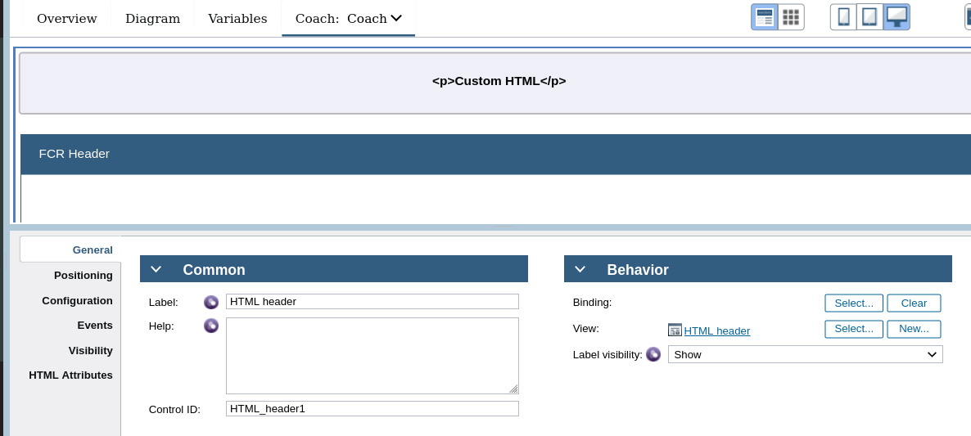

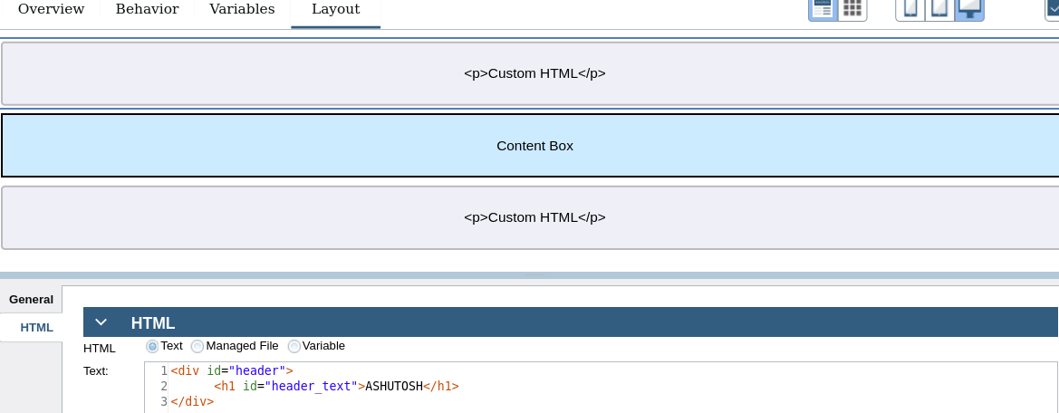

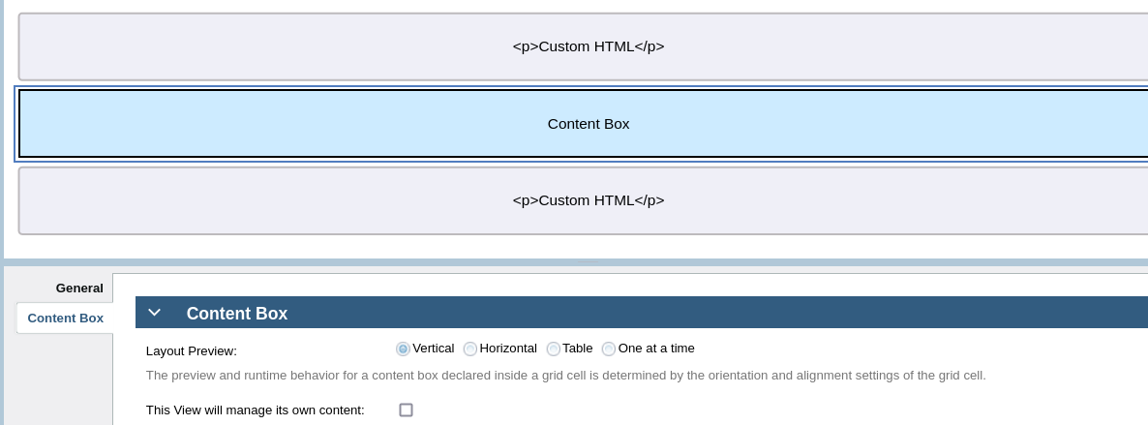

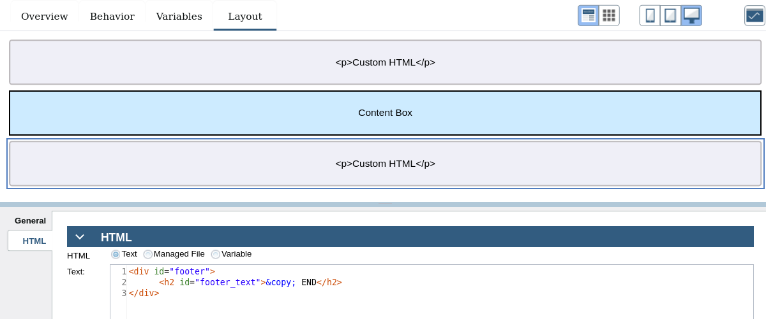

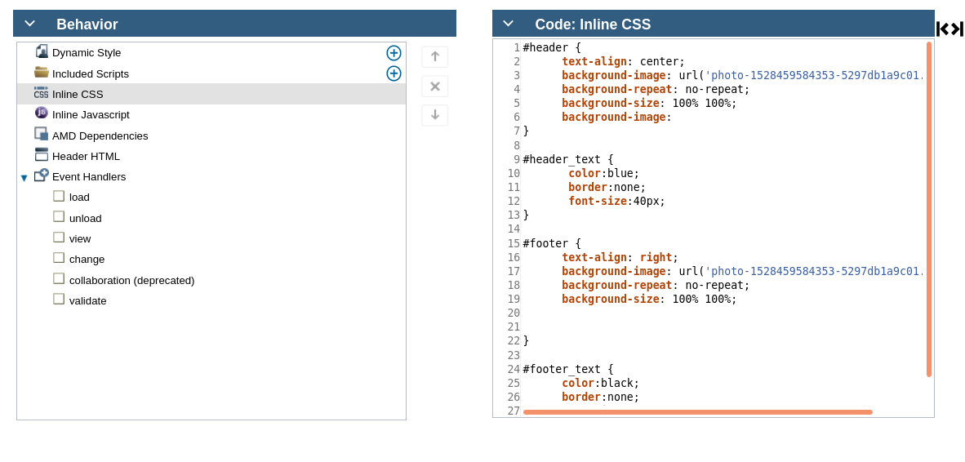

#header {
text-align: center;
background-image: url('photo-1528459584353-5297db1a9c01.jpg');
background-repeat: no-repeat;
background-size: 100% 100%;
background-image:
}

#header_text {
color:blue;
border:none;
font-size:40px;
}

#footer {
text-align: right;
background-image: url('photo-1528459584353-5297db1a9c01.jpg');
background-repeat: no-repeat;
background-size: 100% 100%;

}

#footer_text {
color:black;
border:none;
font-size:12px;
}

Html header

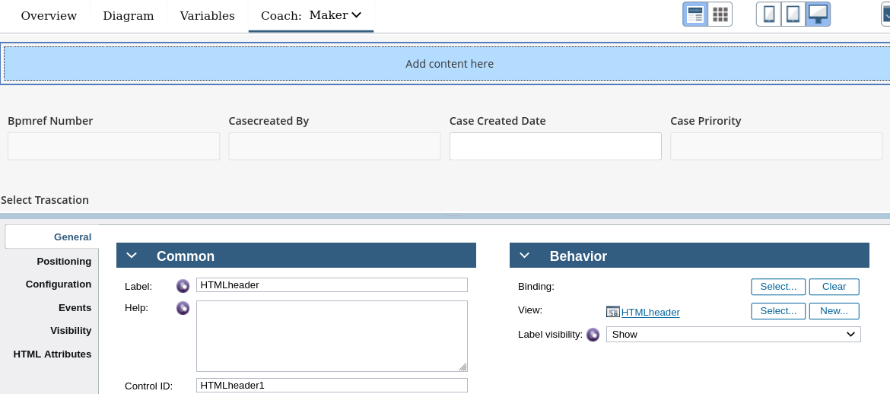

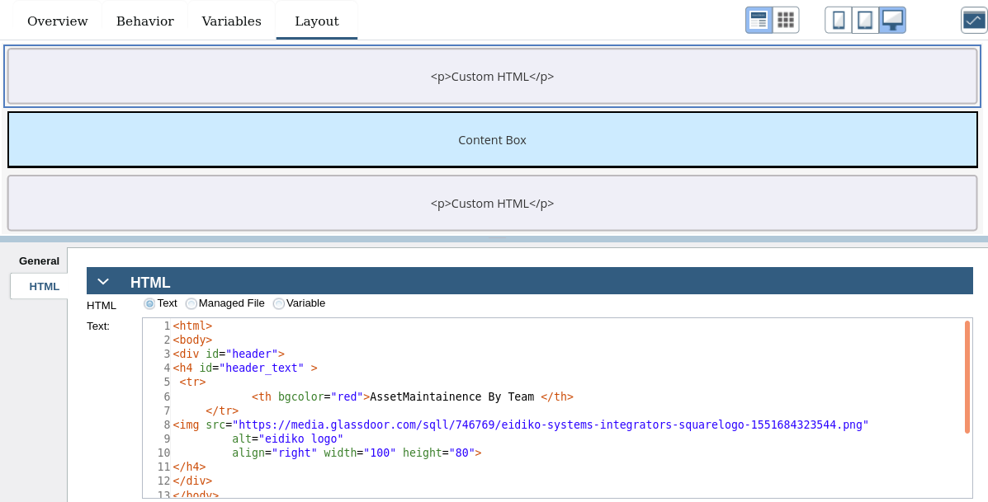

<html>
<body>
<div id="header">
<h4 id="header_text" >
<tr>
<th bgcolor="red">AssetMaintainence By Team </th>
</tr>
<img src="https://media.glassdoor.com/sqll/746769/eidiko-systems-integrators-squarelogo-1551684323544.png"
alt="eidiko logo"
align="right" width="100" height="80">
</h4>
</div>
</body>
</html>

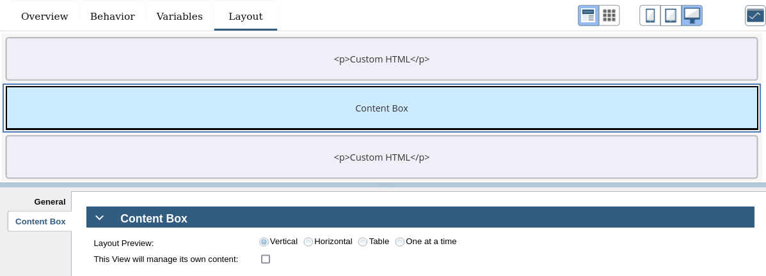

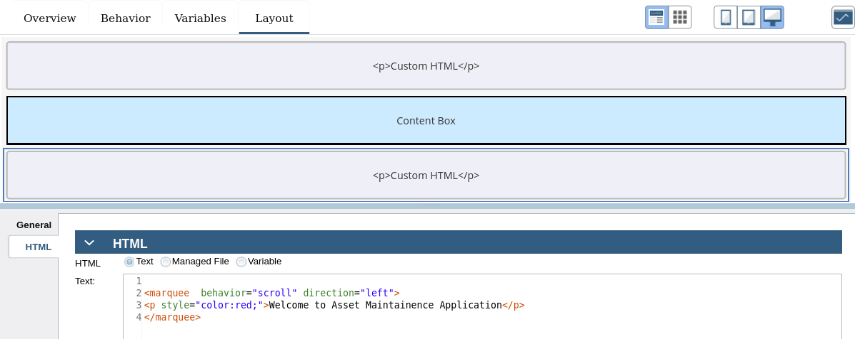

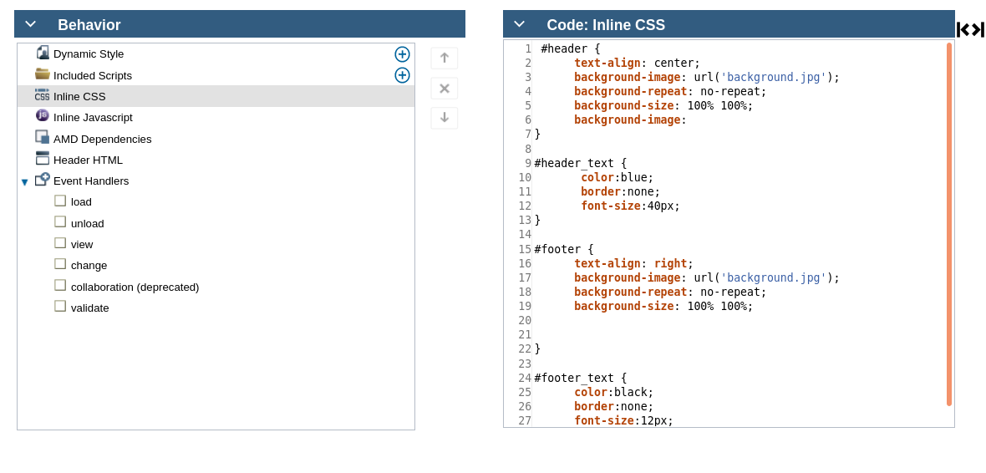

#header {
text-align: center;
background-image: url('background.jpg');
background-repeat: no-repeat;
background-size: 100% 100%;
background-image:
}

#header_text {
color:blue;
border:none;
font-size:40px;
}

#footer {
text-align: right;
background-image: url('background.jpg');
background-repeat: no-repeat;
background-size: 100% 100%;

}

#footer_text {
color:black;
border:none;
font-size:12px;
}

